An Analysis of World Universities Rankings and A Scientometric Analysis of Astronomy and Astrophysics in India, under the supervision of Prof. T.A. Abinandanan and Prof. Subbiah Arunachalam (Visiting Professor, DST-CPR), respectively.

DST-CPR Project Report

Nov 2015 - May 2018

Abinitha Shivakumar

Abstract

This report documents my work done from October 2015 – June 2018, at the Centre for Policy Research – Indian Institute of Science, under the guidance of Prof. Abinandanan T. A., coordinator of the centre, Prof. Arunachalam, visiting professor and Mr Madan M., visiting scientist at the centre.

Three projects were undertaken during this time and are listed below:

* Documentation and analysis of world university rankings (2008-2018) with focus on performance of Indian universities
* Scientomeric analysis of astronomy and astrophysics research in India (2006-2015)
* Triple Helix of innovation for Bioenergy: A comparative study of USA, China, Brazil, India and Europe (1967-2017)

The three projects have been documented and explained in technical detail in the report. The last two are being made into scientific papers to be published subsequently. A complete listing of data files with formats, libraries, dependencies and scripts written will be discussed within the report.

Table of Contents

Section 1: Documentation and analysis of world university rankings 4

Overview of Rankings organizations and their methodologies: 4

ARWU 4

THE Rankings 5

QS Rankings 6

Data collection and documentation 7

THE (Times Higher Education): 7

SHANGHAI: 8

QS: 9

Analysis 9

Consistency Analysis: 9

Analysis in HTML: 13

HTML Graphs 13

Bubble Graph 13

Scatterplots 14

Dropdown Graphs 15

Comparative analysis 17

Overall score vs. Metric score: 17

Overall score vs. Rank: 17

Metric score vs. metric rank: 18

C-Index vs. C-Rank: 19

Analysis of Indian universities 19

Gnuplot: 21

TOP200- QSvsTHE: 22

Rank Compare: 22

SciVal Data: 22

IIT: 22

Central Universities: 23

Indian Institute of Science 23

IISERs: 23

State Universities: 23

Section 2: Scientometric analysis of astronomy and astrophysics research in India (2006-2015) 24

Strategy: 24

Tables and Charts: 30

Images and Graphs: 51

A&A Data-Plain Text: 59

InCites Data: 59

Folders Hierarchy: 59

# Section 1: Documentation and analysis of world university rankings

The first section deals with the documentation and analysis of world university rankings (2008-2018), with focus on performance of Indian universities.

## Overview of Rankings organizations and their methodologies:

University rankings are published by three major freely available professional organizations. They are as follows:

* [Academic Ranking of World Universities (ARWU)](http://www.shanghairanking.com/)
* [Times Higher Education World University Rankings](http://www.timeshighereducation.co.uk/world-university-rankings/)
* [QS World University Rankings](https://www.topuniversities.com/qs-world-university-rankings)

These organizations evaluate universities on a large number of factors, based on their methodologies. The factors analyzed include academic reputation surveys, scholarly publications, paper citations, international collaboration, doctoral degrees, industry income, faculty-student ratio, international students and many more. Each institution has a different methodology which includes or gives significance to some factors over others, resulting in each university’s ranking varying considerably across platforms. This imprecision arises as there is no universally agreed upon measure of teaching and research. Measuring of abstract concepts like institutional reputation is not one that is established but controversial and hotly debated over.

ARWU is an influential ranking list of world universities compiled by Shanghai Jiao Tong University (SJTU). Each year, the top 500 universities in the world are ranked based on a set of criteria:

|  |  |  |  |
| --- | --- | --- | --- |
| **Criteria** | **Indicator** | **Code** | **Weight** |
| Quality of Education | Alumni of an institution winning Nobel Prizes and Fields Medals | Alumni | 10% |
| Quality of Faculty | Staff of an institution winning Nobel Prizes and Fields Medals | Award | 20% |
| Highly cited researchers in 21 broad subject categories | HiCi | 20% |
| Research Output | Papers published in Nature and Science* | N&S | 20% |
| Papers indexed in Science Citation Index-expanded and Social Science Citation Index | PUB | 20% |
| Per Capita Performance | Per capita academic performance of an institution | PCP | 10% |
| Total |  |  | 100% |

Table

More details on the data collection and methodology can be found at: <http://www.shanghairanking.com/ARWU-Methodology-2017.html>

THE Rankings is a ranking list compiled by UK Times Higher Education (THE). In 2010, THE split from its previous partner Quacquarelli Symonds and started to collaborate with Thomson Reuters to create a separate ranking list based on a new set of assessing criteria:

|  |  |
| --- | --- |
| **Criteria** | **Weight** |
| Teaching - the learning environment | 30% |
| Research - volume, income and reputation | 30% |
| Citations - research influence | 30% |
| Industry income – innovation, knowledge transfer | 2.5% |
| International outlook - staff, students and research | 7.5% |
| Total | 100% |

Table

Teaching, Research and International outlook is further divided into the following subcategories:

**Teaching (the learning environment): 30%**

* Reputation survey: 15%
* Staff-to-student ratio: 4.5%
* Doctorate-to-bachelor’s ratio: 2.25%
* Doctorates-awarded- to-academic-staff ratio: 6%
* Institutional income: 2.25%

**Research (volume, income and reputation): 30%**

* Reputation survey: 18%
* Research income: 6%
* Research productivity: 6%

**International outlook (staff, students, research): 7.5%**

* International-to-domestic-student ratio: 2.5%
* International-to-domestic-staff ratio: 2.5%
* International collaboration: 2.5%

More details on the data collection and methodology can be found at: <https://www.timeshighereducation.com/world-university-rankings/methodology-world-university-rankings-2018>

QS Rankings is a university rankings list published by Quacquarelli Symonds as an independent publisher since 2010. The 400 world top universities are ranked every year based on six criteria:

|  |  |  |
| --- | --- | --- |
| **Indicator** | **Elaboration** | **Weight** |
| Academic peer review | Based on an internal global academic survey | 40% |
| Faculty/Student ratio | A measurement of teaching commitment | 20% |
| Citations per faculty | A measurement of research impact | 20% |
| Employer reputation | Based on a survey on graduate employers | 10% |
| International student ratio | A measurement of the diversity of the student community | 5% |
| International staff ratio | A measurement of the diversity of the academic staff | 5% |

Table

More details on the data collection and methodology can be found at: <https://www.topuniversities.com/qs-world-university-rankings/methodology>

## Data collection and documentation

***NOTE: All data is stored under parent folder: SECTION 1: CPR-WUR.***

WUR (World university rankings) are sourced from the following three major publishers:

* THE
* SHANGHAI
* QS

The university rankings published from 2011 to 2018 have been downloaded from each of the rankings websites and documented in the folder WUR (World University Ranking).

Web scraper tool: Data Miner – a Google chrome extension which scrapes selected data as a csv file. For websites which use pagination, use Scrapy or the BeautifulSoup tool in python.

File format: Comma separated value files (CSV)

Each year’s rankings data is stored under the subfolders Shanghai, QS and THE. The filename of the document indicates the publisher and year of publication. For example, THE’s 2011 rankings for the top 200 universities along with their assessing criteria score is stored under the filename ‘THE-2011.csv’ in the subfolder THE.

*Path:SECTION1: CPR-WUR -> WUR -> THE -> THE-2011.csv or ‘SECTION1:CPR-WUR\WUR\THE\THE-2011.csv’*

#### THE (Times Higher Education):

The THE csv files contain a list of institutions ordered by their ranks for that year. The institution is evaluated on Teaching, International Outlook, Research, Citation, Industry Income and an Overall score. Figure 1 is an example of the rankings data.

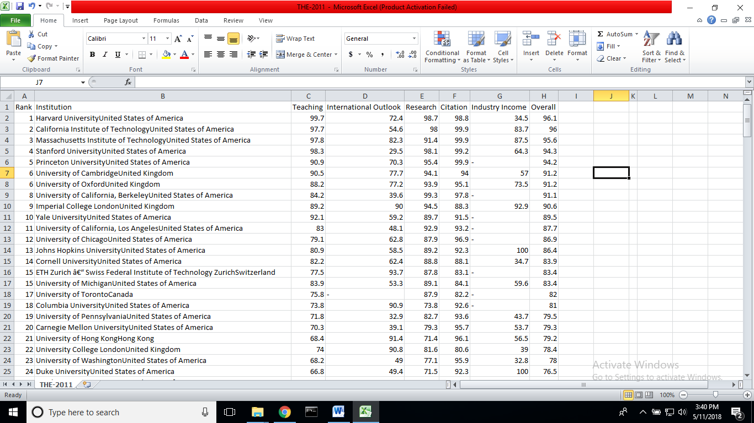

Figure

#### SHANGHAI:

The Shanghai csv files contain a list of institutions ordered by their World Rank. The institution is evaluated on Overall, Alumini, Award, HiCi, N&S, PUB and PCP scores (See Table 1). A screenshot of the Shanghai rankings data file is shown below in Figure 2.

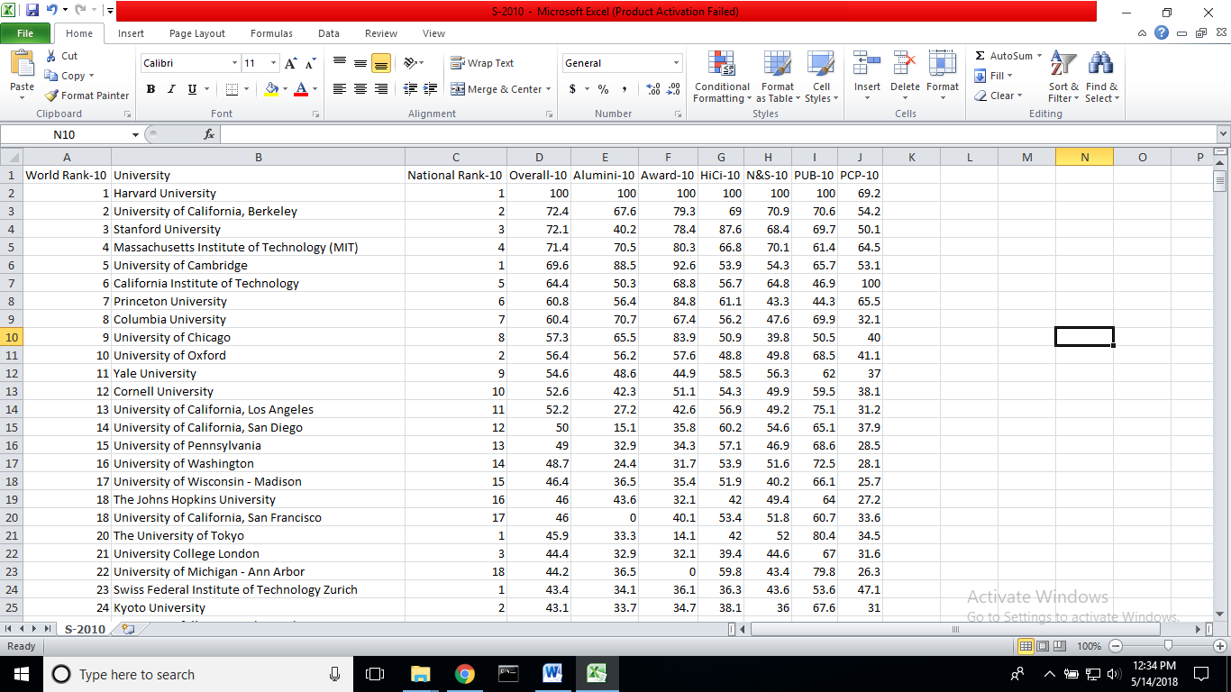

Figure

#### QS:

The QS csv data files, similar to that of THE and Shanghai are lists of universities and their rankings along with other metrics such as Academic reputation, Employer reputation, Faculty Student ratio etc. There is a data file present for each year between 2012 and 2018. A screenshot is as shown below in Figure 3.

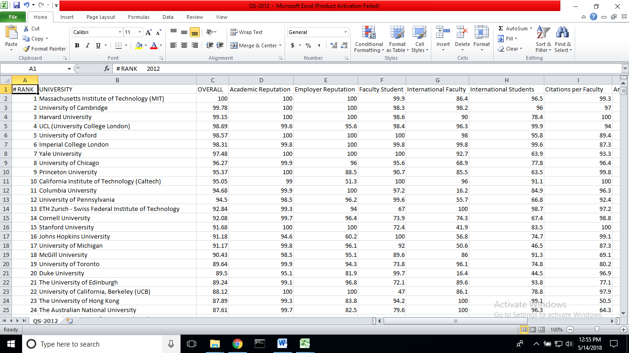

Figure

## Analysis

### Consistency Analysis:

The consistency of the data was analyzed by comparing two consecutive years’ ranking and metrics data. The formula for consistency metric or the variability index is given below:

${(V)}^{2}= \frac{1}{N}\sum_{i}{{\left[\frac{{Rank}_{i}^{n}- {Rank}_{i}^{n+1}}{{Rank}_{i}^{n}}\right]}^{2}}$ Equation

The above calculations have also been done by obtaining the absolute value of $\frac{{ Rank}_{i}^{n}- {Rank}_{i}^{n+1}}{{Rank}_{i}^{n}}$

$V^{*}= \frac{1}{N} \sum_{i}{\left[abs\left(\frac{{Rank}_{i}^{n}- {Rank}_{i}^{n+1}}{{Rank}_{i}^{n}}\right)\right]}$ Equation

The calculations have been done using Microsoft Excel. The table for THE, QS and Shanghai rankings have been tabulated in the following table:

|  |  |  |  |
| --- | --- | --- | --- |
| Ranking | Year | Variability Index - V | Variability Index - V* |
| THE | 2011_2012 | 0.408 | 0.273 |
| THE | 2012_2013 | 0.199 | 0.148 |
| THE | 2013_2014 | 0.171 | 0.117 |
| THE | 2014_2015 | 0.134 | 0.095 |
| THE | 2015_2016 | 0.354 | 0.242 |
| THE | 2016_2017 | 0.185 | 0.128 |
| THE | 2017_2018 | 0.143 | 0.098 |
|  |  |  |  |
| QS | 2013_2014 | 0.111 | 0.074 |
| QS | 2014_2015 | 0.247 | 0.153 |
| QS | 2015_2016 | 0.098 | 0.073 |
| QS | 2016_2017 | 0.0960 | 0.0723 |
|  |  |  |  |
| Shanghai | 2010_2011 | 0.128 | 0.064 |
| Shanghai | 2011_2012 | 0.045 | 0.031 |
| Shanghai | 2012_2013 | 0.060 | 0.034 |
| Shanghai | 2013_2014 | 0.102 | 0.076 |
| Shanghai | 2014_2015 | 0.055 | 0.038 |
| Shanghai | 2015_2016 | 0.157 | 0.114 |
| Shanghai | 2016_2017 | 0.138 | 0.098 |

The data was then visualized using three different programs GNUPLOT, HTML CSS JAVASCRIPT and PYTHON. The HTML versions for the visualization can be found under the folder Consistency Analysis –HTML. For reasons of ease of handling, I stuck to using GNUPLOT scripting to visualize the graphs for the following years. The versions in Gnu plot are documented with images and script files in the Consistency Analysis folder. Each year’s ranking is compared with its previous years ranking and visualized. The files are distributed under the rankings publishers name with year of publishing indicated in the title as well.

The consistency analysis has also been done for the metrics published by THE, QS and Shanghai. Metric scores replace the rank scores and are analyzed for consecutive years. An example from each has been shown below. The symbols σ 1 and σ2 represent V* and V respectively. The blue triangles in the images represent the position of Indian Universities. The red filled circles represent non-Indian universities.

Figure 4 represents Shanghai rankings’ PUB scores for 2016 versus 2015. Figure 5 represents QS rankings’ rank score for 2016 and 2017 being compared. Figure 6 represents THE rankings’ 2017 and 2018 research scores being compared for consistency. The line running diagonally across the graph is the line of best fit. The points lying closest to the line represent a predicted score with little or no variation over the two consecutive years.

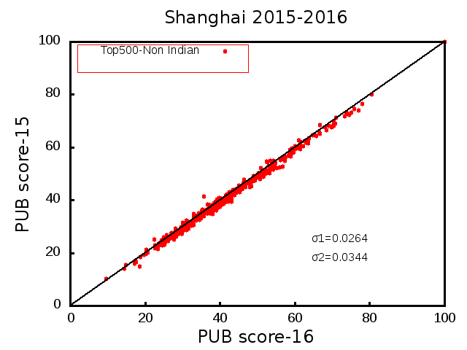

Figure

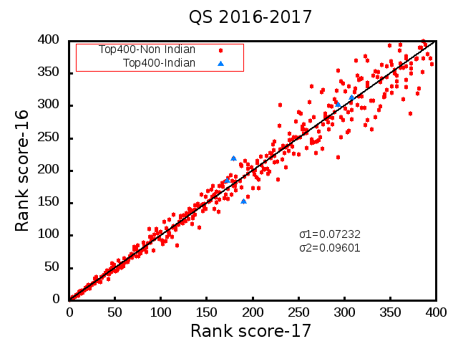

Figure

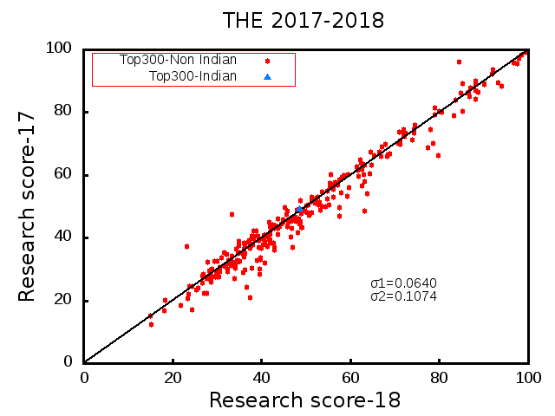

Figure

Folder location: SECTION1: CPR-WUR\Analysis\**Consistency analysis**

Subfolders:

* **C.A New** (Consistency Analysis of THE, QS, Shanghai using gnuplot with variation index denoted) and an excel file ConsistencyTabulationMain.xlsx
* **Metric Consistency-HTML** (Visualizing metric consistency of 2015-16 QS,THE and Shanghai rankings using HTML:)
* **Old-C. A.** (QS, THE, Shanghai 2015-16)- old graphs for consistency analysis plotted using gnuplot without variation index

### Analysis in HTML:

An exercise was done to host the documentation of CPR’s work on a webpage. This was extended to the analysis of rankings for THE, QS and Shanghai.

#### HTML Graphs

I managed to visualize a couple of visually appealing graphs. They are listed below:

##### Bubble Graph

A Bubble graph showing variation in ranks for an institution over a 2 year period was visualized. The size of the bubble demonstrated the change in ranks. Bigger the jump in the rank, bigger is the size of the bubble. The colors have no specific significance.

As depicted in Figure 7, THE rankings data is visualized and a hover function shows the name of the university, its 2015 and 2016 ranks and the difference between them. The size is indicative of how large or small the bubble is for that university. For example, on hovering on University of Arizona’s bubble, the 2015 rank – 86 and 2016 rank – 163 and the difference between the ranks – 77 is displayed.

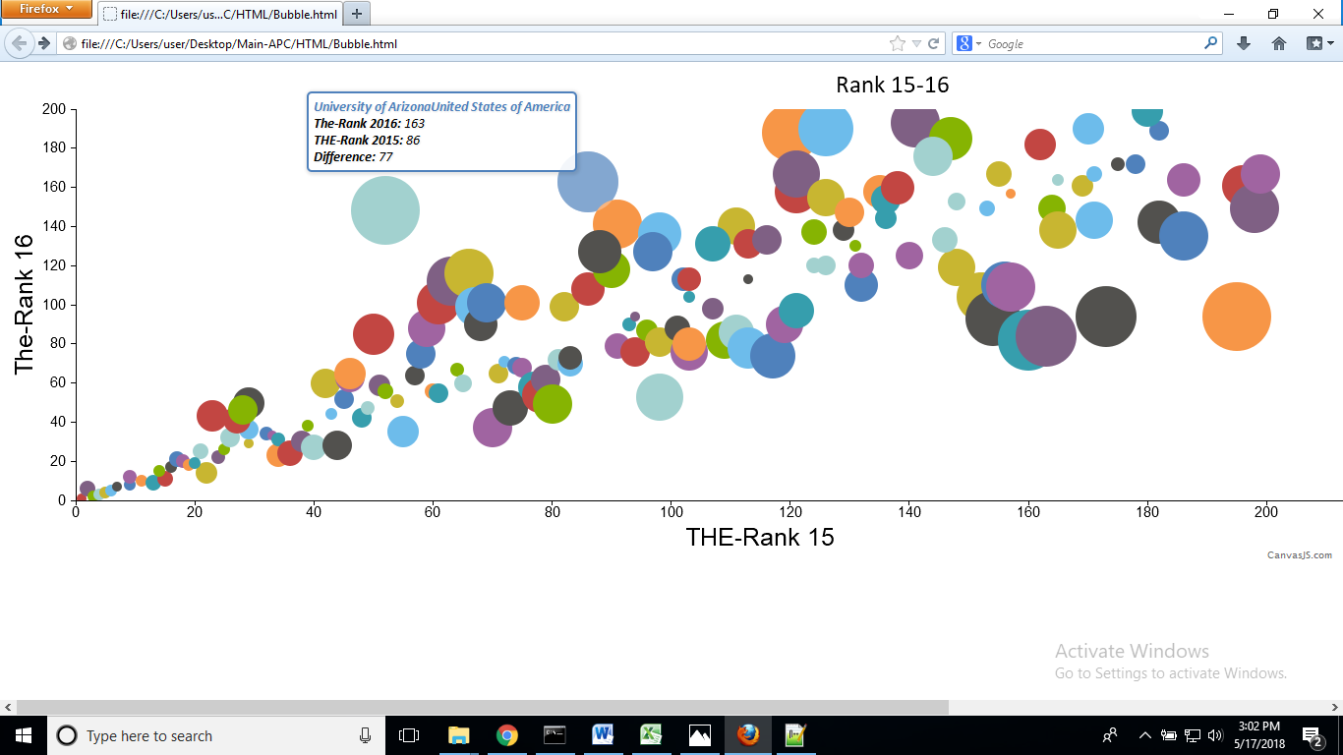

Figure

Code: HTML, CSS and JavaScript

Filename: Bubble.html

Location: SECTION1: CPR-WUR\HTML\Bubble.html

Browser: Firefox

Required additional Javascript files: canvasjs.min, jquery.canvasjs.min, jquery-1.12.3.min (All present in the HTML folder)

A simple ajax (jQuery) ‘GET’ function has been used to read the CSV data file. The code processes and renders the data as rows and columns to a chart container to display the above image. For more examples, please refer ChartJS or CanvasJS. W3school tutorials are a good place to start for understanding the code for beginners.

##### Scatterplots

Scatterplots are plots of two columns of data, scattered as small scatter points across the graph. Figure 8 and Figure 9 show scatter plots for similar ranking data for THE 2014 and 2015. They also include hover on scatter point feature.

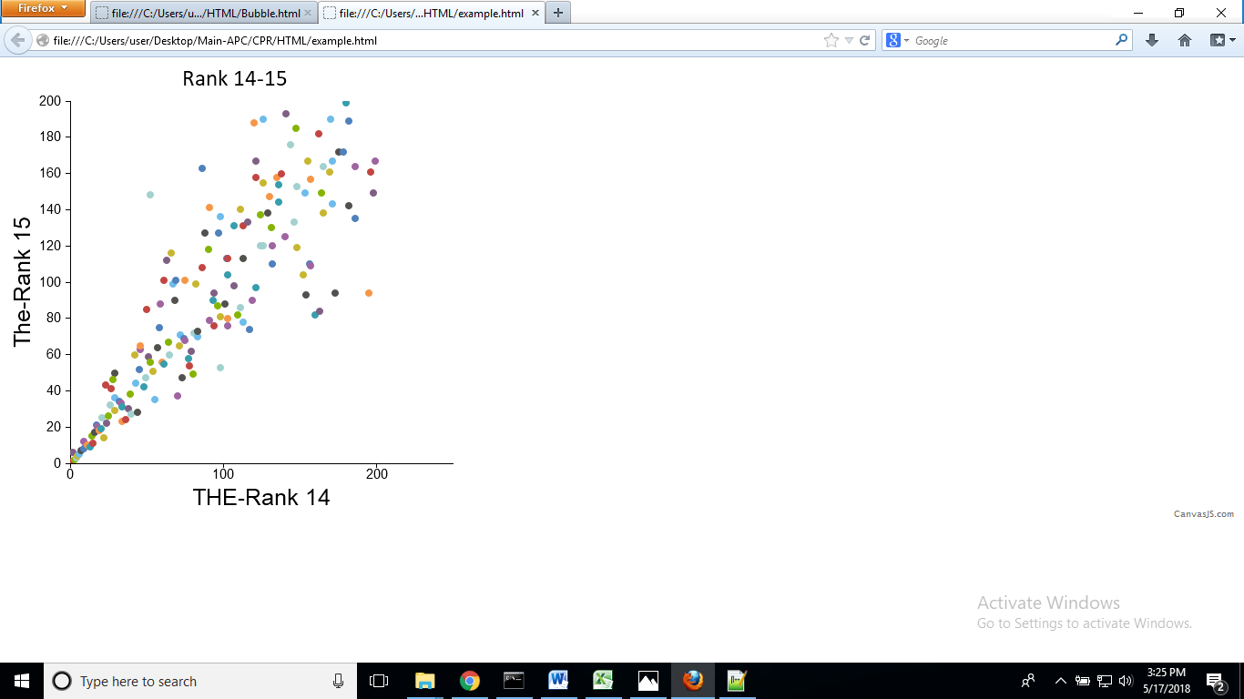

Figure

Figure 9 shows a scatter plot with a conical focus on the universities which have the least variation in rankings over the two consecutive years and the universities that lie outside the cone have the most variation.

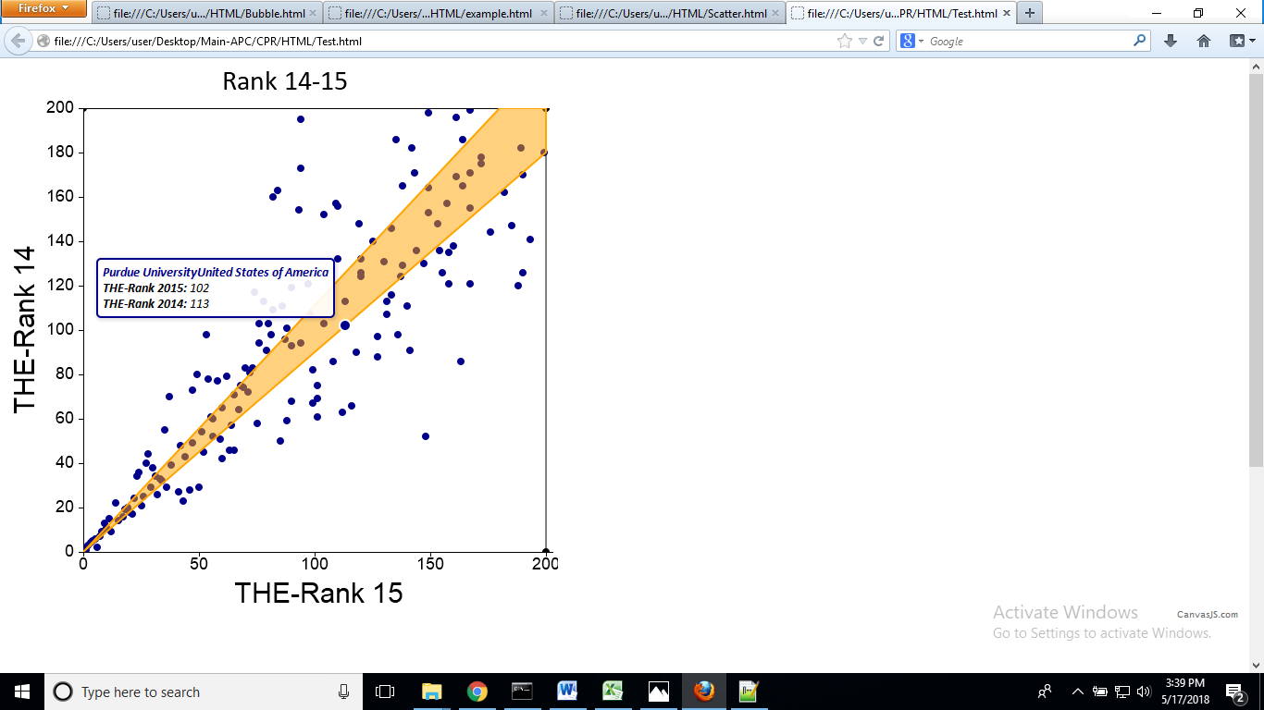

Figure

##### Dropdown Graphs

Dropdown graphs feature a menu option. On clicking the menu button, multiple graphs can be produced. The first kind, Figure 10, features one graph below the other. The second kind, Figure 11, displays buttons with publisher and each of the metrics on them. User can then choose which graph they want to view. The graphs are overwritten on and therefore, multiple graphs cannot be viewed at the same time.

Figure 10 location: SECTION1: CPR-WUR\HTML\Others\THE-QS-Shanghai(17 vs. 18)\THE\Dropdown.html

Figure 11 location: SECTION1: CPR-WUR\HTML\Others\THE-QS-Shanghai(17vs. 18)\QS\Dropdown.html

Note: All required dependent files are present in each folder.

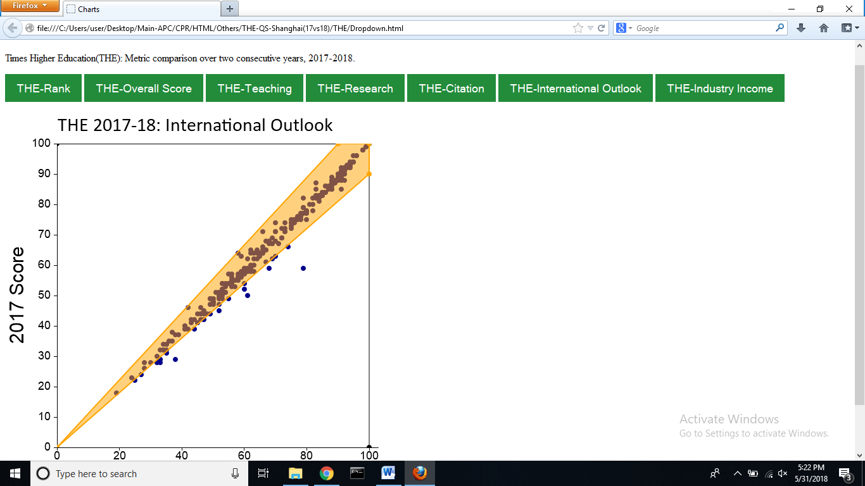

Figure

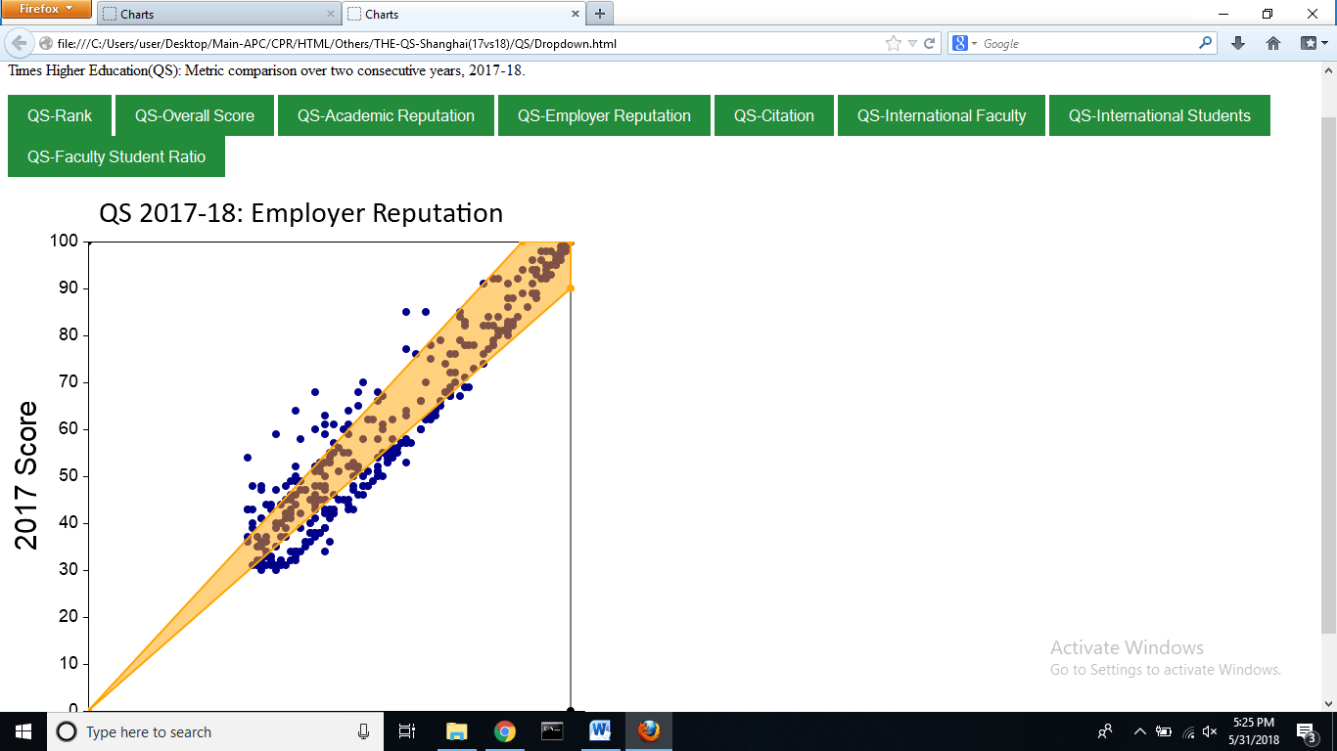

Figure

The above graphs are available for all three rankings publishers and their latest years.

### Comparative analysis

Overall score vs. Metric score: Each metric of the 2015-16 QS, THE Rankings have been plotted against the Overall Score. The larger the scatter, the lesser is the co-relation between the two scores.

Folder location: SECTION1: CPR-WUR\Analysis\ Comparitive analysis \Overall vs Metric (THE,QS 2015-16)

Files included: QS and THE files in separate folders with CSV files for each metric, a parent file .xslx file with all metrics, a python file (Rankcompare.py) with code to visualize the metrics and an images folder with resultant plots.

An example plot (Figure 12) for Overall vs. Metric score for QS 2015-16 ranking is shown below:

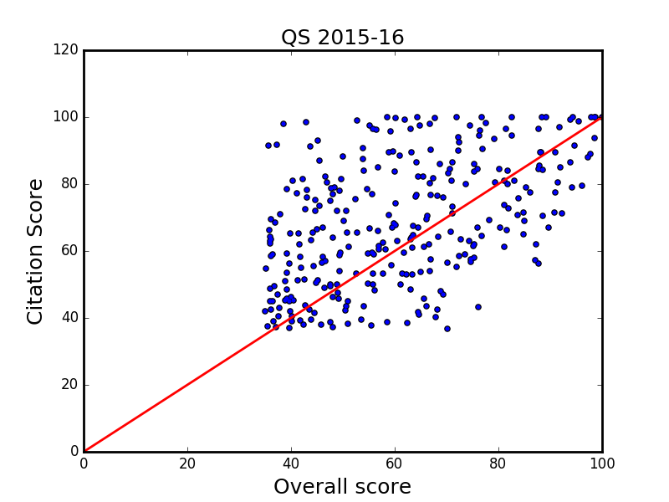

Figure

Overall score vs. Rank: A comparison between Rank and Overall Score for the year 2015-16, of QS and THE Rankings. The green line running across the graph indicates the line of best fit.

Folder location: SECTION1: CPR-WUR\Analysis\Comparative analysis\Overall vs Rank (THE,QS 2015-16)

Files included: THE 2015-16 Rank, QS 2015-16 Rank csv files, images of the plots, and the python program code to plot the graphs.

An example plot (Figure 13) of Overall score vs. Rank for THE 2016 rankings is shown below:

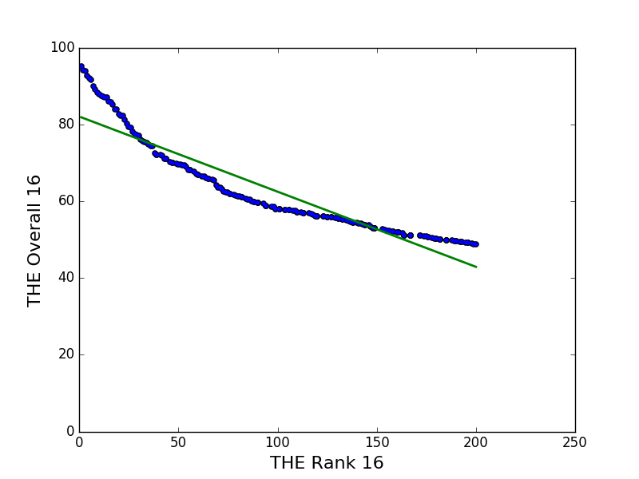

Figure

Metric score vs. metric rank: Each Metric, for the latest year (2015-2016), of QS, THE and Shanghai rankings is assigned a Metric Rank against the score. Arrange the Metric Scores in descending order and number them to get the Metric Rank. The green line running across the graph indicates the line of best fit.

Folder location: SECTION1: CPR-WUR\Analysis\Comparative analysis\Metric score vs metric rank

Files included: Separate folders for QS, THE and Shanghai each containing csv files for each metric, an Images folder with the plots, the python program code to plot the graphs and a READ ME file.

An example plot (Figure 14) for citation score vs. citation rank is shown below:

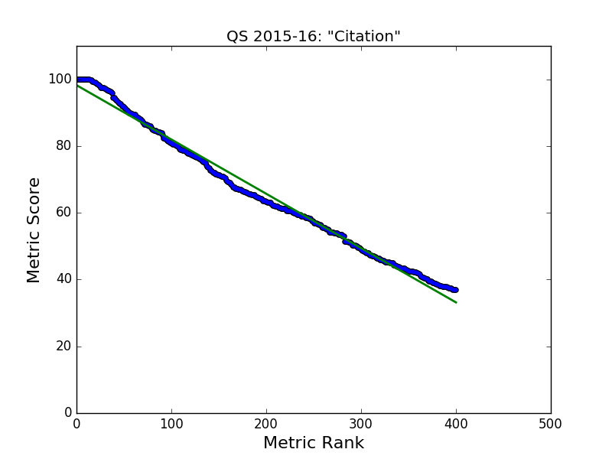

Figure

C-Index vs. C-Rank: Citation Scores for the latest year (2016) are assigned a corresponding index value and compared. This is done for Shanghai, THE and QS Rankings. Citation index is obtained by arranging citation scores in descending order and numbering them (1-200) (index).The green line running across the graph indicates the line of best fit.

Folder location: SECTION1: CPR-WUR\Analysis\Comparative analysis\Metric score vs metric rank\C-Index vs C-Rank

Files included: Separate files for QS, THE and Shanghai containing the Citation index and rank value, an Images folder with the plots, the python program code to plot the graphs and a READ ME file.

An example plot (Figure 15) for citation score vs. citation rank is shown below:

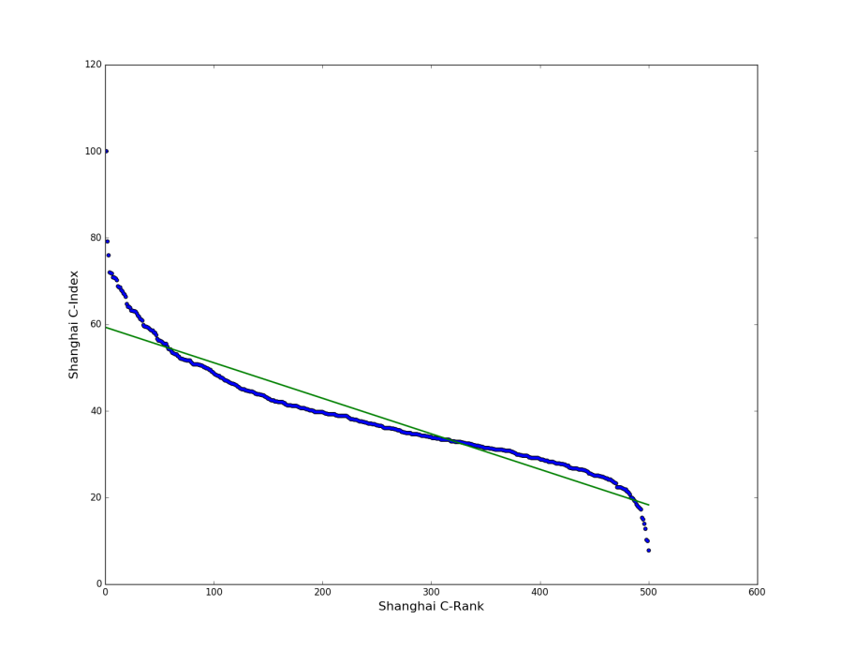

Figure

### Analysis of Indian universities

Universities from India that figured in the World rankings were plotted separately to understand which metrics the universities surged ahead and which ones they lagged in.

Folder location: SECTION1: CPR-WUR\Analysis\Indian Universities

Figure 16 shows Indian Institute of Science (IISc) Bangalore, Indian Institute of Technology Delhi (IITD), Indian Institute of Technology Bombay (IITB), Indian Institute of Technology Madras (IITM), Indian Institute of Technology Kanpur (IITK), Indian Institute of Technology, Kharagpur, Indian Institute of Technology Roorkee (IITR), University of Delhi, Jawaharlal Nehru University, University of Mumbai and Indian Institute of Technology Guwahati (IITG)with metric scores as published by QS rankings 2015-16.

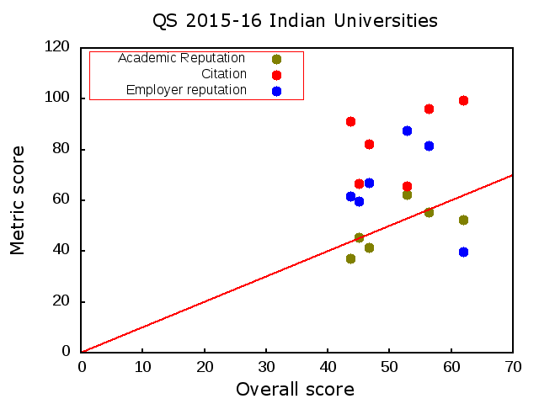

Figure

The above plot has been obtained by using a gnuplot script. The red line indicates the halfway mark of the scores.

Folder location: SECTION1: CPR-WUR\Analysis\Indian Universities\QS-Indian_Universities

Folder contents: All required files to plot the above graph including the gnuplot script.

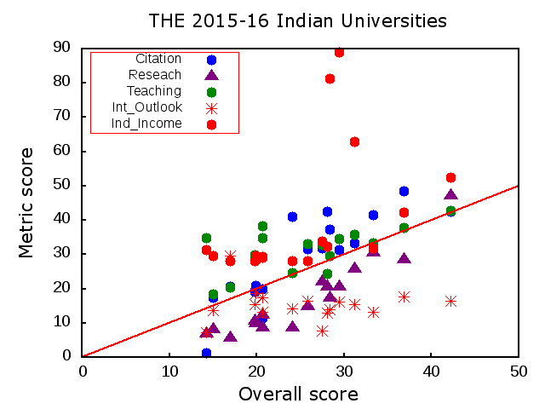

Figure

Figure 17 depicts the Indian universities that appear in THE rankings for 2015-16. From the graph it is inferable that International outlook scores and research scores for the universities are below the average value but all universities fare well in the Industry income metric.

Folder location: SECTION1: CPR-WUR\Analysis\Indian Universities\QS-Indian_Universities

Folder contents: All required files to plot the above graph including the gnuplot script.

### Gnuplot:

A number of countries from the top 100 universities and top 200 universities were selected and their overall scores compared with their international outlook. The plot has been visualized in gnuplot. The script for the same is in the folder with respective dependent files.

Folder location: SECTION1: CPR-WUR\Analysis\GNUPLOT\THE100

Script must be loaded in Gnuplot under the command – load “Script.txt”

Image can be saved by setting term to png.

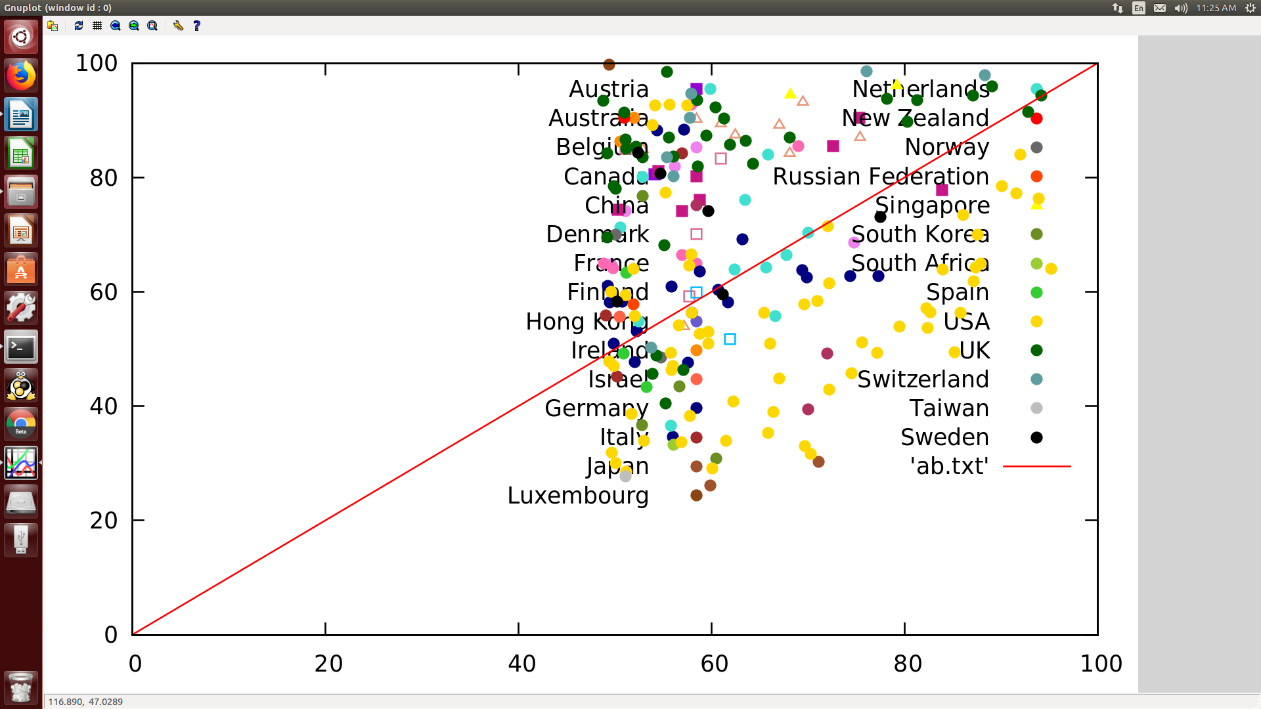

Figure

### TOP200- QSvsTHE:

Each of the metrics of QS and THE were compared for different universities to see how they performed across the wo companies.

Folder location: SECTION1: CPR-WUR\Analysis\TOP200- QSvsTHE

### Rank Compare:

The ranks of universities were compared with the ranks of their previous years. This exercise was repeated under consistency analysis with all metrics included.

### SciVal Data:

SciVal- An Elsevier database was used to extract data on IIT’s, IISER’s, Central Universities and IISc. SciVal gave access to research performance and statistical data on each of the universities.

Folder Location: Section1: CPR-WUR/SciVal Data

The universities are listed as follows:

#### IIT:

IIT Kharagpur

IIT Bombay

IIT Kanpur

IIT Madras

IIT Delhi

IIT Guwahati

IIT Roorkee

#### Central Universities:

Assam University, Silchar

Tezpur University

Jamia Millia Islamia, New Delhi

Jawaharlal Nehru University, New Delhi

University of Delhi, New Delhi

Guru Ghasidas Vishwavidyalaya, Bilaspur

Pondicherry University, Puducherry

Aligarh Muslim University

Babasaheb Bhimrao Ambedkar University, Lucknow

Banaras Hindu University, Varanasi

Visva Bharati, Shantiniketan

Rajiv Gandhi University, Itanagar

Dr. Harisingh Gour Vishwavidyalaya, Sagar

Manipur University, Imphal

Hemwati Nandan Bahuguna Garhwal University, Garhwal

University of Hyderabad

#### Indian Institute of Science

#### IISERs:

IISER -Bhopal

IISER -Pune

IISER - Mohali

IISER - Thiruvananthapuram

#### State Universities:

Jadhavpur University

Mumbai University

University of Calcutta

University of Madras

# Section 2: Scientometric analysis of astronomy and astrophysics research in India (2006-2015)

The database of Web of Science (WoS) was used to procure the scientific papers related to Astronomy and Astrophysics (A&A). The WoS database covers three databases and over 12,000 journals that include citation references, affiliations of institutions, collaboration between countries, data on the authors etc. and was the obvious source for the research. We have selected the scientific papers related to A&A that were identified among all papers indexed in WoS, to provide the essential indicators for the Bibliometric study.

***NOTE: All data is stored under the parent folder: SECTION 2-Scientometrics Astronomy & Astrophysics***

### Strategy:

A bibliometric method was used to obtain publications in astronomy and astrophysics for the period 2006-2015 using a set of Journals and keywords to extract papers from the database.

**Astronomy and Astrophysics research in India**

**7 July 2017**

**Method:**

**DOCUMENT TYPES:** ARTICLE *OR* REVIEW *OR* LETTER *OR* PROCEEDINGS PAPER

**DATABASE:** SCIENCE CITATION INDEX EXPANDED

**YEAR:** 2006-2015

**#1 (61 Journals)**

SO = ("ACTA ASTRONOMICA" OR "ADVANCES IN ASTRONOMY" OR "ADVANCES IN SPACE RESEARCH*" OR "ANNUAL REVIEW OF ASTRONOMY AND ASTROPHYSICS*" OR "ASTROBIOLOGY" OR "ASTRONOMICAL JOURNAL" OR "ASTRONOMISCHE NACHRICHTEN" OR "ASTRONOMY & ASTROPHYSICS" OR "ASTRONOMY & GEOPHYSICS" OR "ASTRONOMY AND ASTROPHYSICS REVIEW" OR "ASTRONOMY LETTERS-A JOURNAL OF ASTRONOMY AND SPACE ASTROPHYSICS" OR "ASTRONOMY REPORTS" OR "ASTROPARTICLE PHYSICS" OR "ASTROPHYSICAL BULLETIN" OR "ASTROPHYSICAL JOURNAL LETTERS" OR "ASTROPHYSICAL JOURNAL SUPPLEMENT SERIES" OR "ASTROPHYSICAL JOURNAL" OR "ASTROPHYSICS AND SPACE SCIENCE" OR "ASTROPHYSICS" OR "BALTIC ASTRONOMY" OR "BULLETIN OF THE ASTRONOMICAL SOCIETY OF INDIA" OR "CELESTIAL MECHANICS & DYNAMICAL ASTRONOMY" OR "CONTRIBUTIONS OF THE ASTRONOMICAL OBSERVATORY SKALNATE PLESO" OR "COSMIC RESEARCH" OR "EARTH MOON AND PLANETS" OR "EXPERIMENTAL ASTRONOMY" OR "GEOPHYSICAL AND ASTROPHYSICAL FLUID DYNAMICS" OR "GRAVITATION & COSMOLOGY" OR "ICARUS" OR "INTERNATIONAL JOURNAL OF ASTROBIOLOGY" OR "INTERNATIONAL JOURNAL OF MODERN PHYSICS D" OR "JOURNAL OF ASTROPHYSICS AND ASTRONOMY" OR "JOURNAL OF COSMOLOGY AND ASTROPARTICLE PHYSICS" OR "JOURNAL OF SPACE WEATHER AND SPACE CLIMATE" OR "JOURNAL OF THE KOREAN ASTRONOMICAL SOCIETY" OR "KINEMATICS AND PHYSICS OF CELESTIAL BODIES" OR "LIVING REVIEWS IN SOLAR PHYSICS" OR "MONTHLY NOTICES OF THE ROYAL ASTRONOMICAL SOCIETY" OR "NEW ASTRONOMY REVIEWS" OR "NEW ASTRONOMY" OR "OBSERVATORY" OR "PHYSICS OF THE DARK UNIVERSE" OR "PLANETARY AND SPACE SCIENCE" OR "PUBLICATIONS OF THE ASTRONOMICAL SOCIETY OF AUSTRALIA" OR "PUBLICATIONS OF THE ASTRONOMICAL SOCIETY OF JAPAN" OR "PUBLICATIONS OF THE ASTRONOMICAL SOCIETY OF THE PACIFIC" OR "RESEARCH IN ASTRONOMY AND ASTROPHYSICS" OR "REVISTA MEXICANA DE ASTRONOMIA Y ASTROFISICA" OR "SERBIAN ASTRONOMICAL JOURNAL" OR "SOLAR PHYSICS" OR "SOLAR SYSTEM RESEARCH" OR "SPACE SCIENCE REVIEWS" OR "SPACE WEATHER-THE INTERNATIONAL JOURNAL OF RESEARCH AND APPLICATIONS" OR "ASTRONOMY AND COMPUTING" OR "JOURNAL OF GEOPHYSICAL RESEARCH SPACE PHYSICS" OR "CHINESE JOURNAL OF ASTRONOMY AND ASTROPHYSICS" OR "JBIS JOURNAL OF THE BRITISH INTERPLANETARY SOCIETY")

**Results:**

**World:** 129,058papers

**#2 (15 journals, 159 keywords)**

SO=("PHYSICAL REVIEW LETTERS" OR "INTERNATIONAL JOURNAL OF MODERN PHYSICS D" OR "LIVING REVIEWS IN RELATIVITY" OR "ANNALES GEOPHYSICAE" OR "ANNUAL REVIEW OF EARTH AND PLANETARY SCIENCES" OR "CLASSICAL AND QUANTUM GRAVITY" OR "COMPTES RENDUS PHYSIQUE" OR "EUROPEAN JOURNAL OF PHYSICS" OR "GENERAL RELATIVITY AND GRAVITATION" OR "MODERN PHYSICS LETTERS A" OR "NUCLEAR PHYSICS B" OR "PHYSICAL REVIEW D" OR "PHYSICAL REVIEW E" OR "PHYSICS LETTERS B" OR "RADIO SCIENCE")

AND TS= ("ABELL CLUSTER*" OR "ACCELERATING UNIVERSE" OR "ACTIVE GALACTIC NUCLEI" OR "AE STAR*" OR "ALPHA CENTAURI*" OR "AM STAR*" OR "ANTI DE SITTER*" OR "ANTI-DE SITTER*" OR "AP STAR*" OR "APOCENT*" OR "ASTERO*" OR "ASTRONOM*" OR "ASTROPARTICLE PHYSIC*" OR "ASTROPHYSIC*" OR "B L LAC*" OR "BARYON ACOUSTIC OSCILLATION*" OR "BEKENSTEIN HAWKING ENTROPY*" OR "BETA PICTORIS" OR "BIANCHI COSMOL*" OR "BIG BANG NUCLEOSYNTHESIS" OR "BIG BANG THEORY" OR "BINARY STAR*" OR "BL LAC*" OR "BLACK HOLE*" OR "BLACKHOLE*" OR "BLAZAR*" OR "BRANEWORLD COSMOLOGY" OR "BRIGNT GIANT*" OR "BROWN DWARF*" OR "CARBON STAR" OR "CIRCUMSTELLAR" OR "CMB ANISOTROPY" OR "CMB POLARIZATION" OR "CMB RADIATION" OR "COMET*" OR "COOL PLANET" OR "COSMIC MICROWAVE BACKGROUND ANISOTROPY" OR "COSMIC MICROWAVE BACKGROUND POLARIZATION" OR "COSMIC MICROWAVE BACKGROUND RADIATION" OR "COSMIC MICROWAVE BACKGROUND*" OR "COSMIC STRING" OR "COSMIC SUPERSTRING*" OR "COSMIC WAVE*" OR "COSMOLOGICAL PERTURBATION*" OR "COSMOS" OR "COSMOLOG*" OR "DARK ENERGY" OR "DARK MATTER" OR "DARK UNIVERSE" OR "DWARF PLANET*" OR "DWARF STAR*" OR "ECLIPS*" OR "EXOPLANET*" OR "EXOSOLAR" OR "EXTRAGALA*" OR "F(R) GRAVITY" OR "GALACT*" OR "GALAX*" OR "GAMMA RAY BURST*" OR "GAMMA-RAY BURST*" OR "GAS GIANT*" OR "GENERAL RELATIVITY*" OR "GIANT STAR*" OR "GLOBULAR CLUSTER" OR "GRAVITATION* WAVE*" OR "GRAVITATION*-WAVE*" OR "GRAVITATIONAL ANOMAL*" OR "GRAVITATIONAL LENSING" OR "GRAVITATIONAL PERTURBATION*" OR "GRAVITY WAVE*" OR "GRB*" OR "HERCULIS STAR*" OR "INTERSTELLAR*" OR "KUIPER BELT*" OR "LASER INTERFEROMETRIC SPACE ANTENNA" OR "LOVELOCK GRAVITY" OR "LOW MASS STAR" OR "LOW SOLAR ACTIV*" OR "LUNAR PERTURBATION*" OR "MARS" OR "MARTIAN" OR "MASSIVE STAR*" OR "METEORIT*" OR "MICROWAVE ANISOTROPY PROBE" OR "MILKY WAY*" OR "MURCHISON WIDEFIELD ARRAY" OR "NEPTUNE" OR "NEUTRINO ASTRONOMY" OR "NEUTRINO DECOUPLING" OR "NEUTRINO MASSES" OR "NEUTRINO OSCILLATIONS" OR "NEUTRINO TELESCOPES" OR "NEUTRON STAR*" OR "NOVA" OR "ORBITAL DECAY" OR "PERSEUS*" OR "PRIMORDIAL NUCLEOSYNTHESIS" OR "PROTOPLANET*" OR "PROTOSTAR" OR "PROTOSTELLAR" OR "PULSAR*" OR "QUANTUM COSMOLOGY" OR "QUASAR" OR "RADAR ASTRO*" OR "RED DWARF*" OR "REDSHIFT SURVEY" OR "RINDLER COORDINATE SYSTEM" OR "RINDLER FRAME" OR "SATURN*" OR "SEYFERT" OR "SKY SURVEY" OR "SOLAR CORONA*" OR "SOLAR CYCLE" OR "SOLAR FLARE*" OR "SOLAR INTERIOR" OR "SOLAR JET*" OR "SOLAR PERTURBATION*" OR "SOLAR PHYS*" OR "SOLAR SYSTEM" OR "SOLAR WIND" OR "STAR CLUST*" OR "STAR HR-799" OR "STARBURST" OR "STARSPOT" OR "STELLAR*" OR "SUBDWARF*" OR "SUBGIANT STAR*" OR "SUNSPOT*" OR "SUPER GIANT STAR*" OR "SUPERGIANT*" OR "SUPERNOV*" OR "TELESCOPE*" OR "TIMESPACE" OR "TITAN" OR "WEAK GRAVITY" OR "WHITE DWARF*" OR "YELLOW DWARF*" OR "ZERO POINT LENGTH" OR "CETI STAR*" OR "PERSEI STAR*" OR "VERY LARGE ARRAY" OR "VLA" OR "N-BODY PROBLEM" OR "THREE-BODY PROBLEM" OR "TWO-BODY PROBLEM" OR "WORMHOLE" OR "SPACETIME" OR "Gravity Probe B" OR "GUILFOYLE* STAR*" ) AND PY=2006-2015

**Results:**

**World:** 31,023 papers

**#3 (Three multidisciplinary journals, 159 keywords and 216 NOT keywords)**

(SO =("NATURE" OR "SCIENCE" OR "PROCEEDINGS OF THE NATIONAL ACADEMY OF SCIENCES OF THE UNITED STATES OF AMERICA" )

AND TS= ("ABELL CLUSTER*" OR "ACCELERATING UNIVERSE" OR "ACTIVE GALACTIC NUCLEI" OR "AE STAR*" OR "ALPHA CENTAURI*" OR "AM STAR*" OR "ANTI DE SITTER*" OR "ANTI-DE SITTER*" OR "AP STAR*" OR "APOCENT*" OR "ASTERO*" OR "ASTRONOM*" OR "ASTROPARTICLE PHYSIC*" OR "ASTROPHYSIC*" OR "B L LAC*" OR "BARYON ACOUSTIC OSCILLATION*" OR "BEKENSTEIN HAWKING ENTROPY*" OR "BETA PICTORIS" OR "BIANCHI COSMOL*" OR "BIG BANG NUCLEOSYNTHESIS" OR "BIG BANG THEORY" OR "BINARY STAR*" OR "BL LAC*" OR "BLACK HOLE*" OR "BLACKHOLE*" OR "BLAZAR*" OR "BRANEWORLD COSMOLOGY" OR "BRIGHT GIANT*" OR "BROWN DWARF*" OR "CARBON STAR" OR "CIRCUMSTELLAR" OR "CMB ANISOTROPY" OR "CMB POLARIZATION" OR "CMB RADIATION" OR "COMET*" OR "COOL PLANET" OR "COSMIC MICROWAVE BACKGROUND ANISOTROPY" OR "COSMIC MICROWAVE BACKGROUND POLARIZATION" OR "COSMIC MICROWAVE BACKGROUND RADIATION" OR "COSMIC MICROWAVE BACKGROUND*" OR "COSMIC STRING" OR "COSMIC SUPERSTRING*" OR "COSMIC WAVE*" OR "COSMOLOGICAL PERTURBATION*" OR "COSMOS" OR "COSMOLOG*" OR "DARK ENERGY" OR "DARK MATTER" OR "DARK UNIVERSE" OR "DWARF PLANET*" OR "DWARF STAR*" OR "ECLIPS*" OR "EXOPLANET*" OR "EXOSOLAR" OR "EXTRAGALA*" OR "F(R) GRAVITY" OR "GALACT*" OR "GALAX*" OR "GAMMA RAY BURST*" OR "GAMMA-RAY BURST*" OR "GAS GIANT*" OR "GENERAL RELATIVITY*" OR "GIANT STAR*" OR "GLOBULAR CLUSTER" OR "GRAVITATION* WAVE*" OR "GRAVITATION*-WAVE*" OR "GRAVITATIONAL ANOMAL*" OR "GRAVITATIONAL LENSING" OR "GRAVITATIONAL PERTURBATION*" OR "GRAVITY WAVE*" OR "GRB*" OR "HERCULIS STAR*" OR "INTERSTELLAR*" OR "KUIPER BELT*" OR "LASER INTERFEROMETRIC SPACE ANTENNA" OR "LOVELOCK GRAVITY" OR "LOW MASS STAR" OR "LOW SOLAR ACTIV*" OR "LUNAR PERTURBATION*" OR "MARS" OR "MARTIAN" OR "MASSIVE STAR*" OR "METEORIT*" OR "MICROWAVE ANISOTROPY PROBE" OR "MILKY WAY*" OR "MURCHISON WIDEFIELD ARRAY" OR "NEPTUNE" OR "NEUTRINO ASTRONOMY" OR "NEUTRINO DECOUPLING" OR "NEUTRINO MASSES" OR "NEUTRINO OSCILLATIONS" OR "NEUTRINO TELESCOPES" OR "NEUTRON STAR*" OR "NOVA" OR "ORBITAL DECAY" OR "PERSEUS*" OR "PRIMORDIAL NUCLEOSYNTHESIS" OR "PROTOPLANET*" OR "PROTOSTAR" OR "PROTOSTELLAR" OR "PULSAR*" OR "QUANTUM COSMOLOGY" OR "QUASAR" OR "RADAR ASTRO*" OR "RED DWARF*" OR "REDSHIFT SURVEY" OR "RINDLER COORDINATE SYSTEM" OR "RINDLER FRAME" OR "SATURN*" OR "SEYFERT" OR "SKY SURVEY" OR "SOLAR CORONA*" OR "SOLAR CYCLE" OR "SOLAR FLARE*" OR "SOLAR INTERIOR" OR "SOLAR JET*" OR "SOLAR PERTURBATION*" OR "SOLAR PHYS*" OR "SOLAR SYSTEM" OR "SOLAR WIND" OR "STAR CLUST*" OR "STAR HR-799" OR "STARBURST" OR "STARSPOT" OR "STELLAR*" OR "SUBDWARF*" OR "SUBGIANT STAR*" OR "SUNSPOT*" OR "SUPER GIANT STAR*" OR "SUPERGIANT*" OR "SUPERNOV*" OR "TELESCOPE*" OR "TIMESPACE" OR "TITAN" OR "WEAK GRAVITY" OR "WHITE DWARF*" OR "YELLOW DWARF*" OR "ZERO POINT LENGTH" OR "CETI STAR*" OR "PERSEI STAR*" OR "VERY LARGE ARRAY" OR "VLA" OR "N-BODY PROBLEM" OR "THREE-BODY PROBLEM" OR "TWO-BODY PROBLEM" OR "WORMHOLE" OR "SPACETIME" OR "Gravity Probe B" OR "GUILFOYLE* STAR*" )

NOT TS=(EARTH* OR ECOLOG* OR BIOLOG* OR METERO* OR ANIMAL* OR "COMET ASSAY*" OR CORONARY* OR ASTROCYTE* OR "STAR SHAPE*" OR NORAL OR "STAR TOPOLOGY" OR "STAR-DELTA" OR "STAR CONNECT*" OR "STAR NETWORK" OR "GRAVITATIONAL SEARCH ALGORITHM" OR "ECLIPSE IDE" OR ASTROCYTE* OR "AURORA KINASE" OR "STAR ANISE" OR "STAR LIKE" OR "STAR TPC" OR "PLANETARY BALL MILL" OR "STELLARATOR" OR "STAR DETECTOR" OR "STAR COLLABORATION" OR STAR EXPERIMENT OR OSDDLINUX OR "COMPACT MUON SOLENOID" OR CMS OR "STAR POLYMER*" OR ASTROCYTOMA* OR ASTROCY* OR "MULTI-AFFINITY REMOVAL SYSTEM" OR ASTROGLIOSIS OR ASTROGLIAL OR "SNOW LEOPARD" OR "AURORA A" OR "STAR SEQUENCES" OR "STEROIDOGENIC ACUTE REGULATORY PROTEIN" OR ASTROVIRUS OR "SUBTYPE ANALYZER STAR" OR "ZORBAX ECLIPSE" OR "PROTEIN BINDING PROTEIN 2" OR SATURNIID OR SATURNIIDAE OR NOVAEGUINEAE OR "MULTI-AMINOACYL-TRNA SYNTHETASE" OR "STAR STATUS" OR D-STAR OR GRAPHENE OR "RISING STAR" OR GENOME OR DNA OR "BETA STAR*" OR "PLANETARY ENERGETIC*" OR "PROTEIN CORONA*" OR SKYRMION* OR PLANETARY-SCALE OR "PLANETARY SCALE" OR ANTARCTIC* OR "SEA STAR*" OR ASTEROIDEAN OR "CEPHEID GENEXPERT" OR "CORONA VIRUS" OR "AURORA B KINASE" OR AURKB OR "AURORA KINASE B" OR LEUKEMIA OR "MULTIVARIATE ADAPTIVE REGRESSION SPLINES" OR "CORONA RADIATA" OR NOVARTIS OR LESION OR AURORA2 OR AURORA1 OR "P31(COMET)" OR "NETWORK COSMOL*" OR "COSMIC COLLAB*" OR DNA OR RNA OR VIRUS OR DINOSAUR* OR "MEDICATION ADHERENCE REPORT SCALE" OR "AIR POLLUTION" OR PATIENT OR "SAMSUNG GALAXY" OR CARNIVOROUS OR SEAWATER OR "SEA WATER" OR MEGARAPTOR OR "TELESCOPING-TIME FRAME" OR ASTROGLIA OR PROTEIN OR BIODIVERSITY OR "CELL MIGRATION" OR CELL OR "BRAINS DARK ENERGY" OR "UK COSMOS" OR "STELLARIA-LONGIPES" OR GALAXIA* OR GALAXEA OR "NOVA SCOTIA" OR SATURNIDAE OR EPIDEMIOLO* OR CORAL* OR "CORE OUTCOME MEASURES FOR EFFECTIVENESS TRIALS" OR CLIMATE* OR METABOLISM OR "BRAIN NETWORK" OR "CORONA RADIATION" OR "TELESCOPIC BAR" OR "CEPHEID XPERT" OR"TELESCOPIC ALGORITHM" OR "PUPIL DILATION" OR "SUNSPOT NUMBER" OR "ANTERIOR CORONA" OR COMETABOLIC* OR BOTAURUS-STELLARIS OR "CELESTIAL ROTATION" OR "PORTABLE DOCUMENT FORMAT" OR "SCYLIORHINUS STELLARIS" OR "DUAL FORMAT JOURNALS" OR "JUPITER FLORIDA" OR "CORONA DISCHARGES" OR "SEA-KEEPING TEST" OR CUNEIFORM OR "CITING BEHAVIOR" OR "NEPTUNE CABLED OBSERVATORY" OR PENCILINE OR "COSMICS LEAVING OUTDOOR DROPLETS" OR "CONSISTENT SALTATION" OR RAINFALL OR "MINERAL NANOPARTICLES" OR "IRON OXIDE*" OR "NEPTUNE MC-ICPMS" OR "KEPLERATE SOLID" OR "GEOLOGICAL SURVEY" OR ASTROLOGY OR "NIKON ECLIPSE" OR EARTHQUAKE OR TSUNAMI OR CYCLONE OR "GANGA RIVER BASIN" OR "ARYAN INVASION THEORY" OR "PILLAR INSCRIPTION" OR "AURORAL ELECTRON" OR "GALILEO'S DISCOURSES" OR "NATIONAL ELIGIBILITY TEST" OR "TIME, SPACE" OR "BY KEPLER" OR "COSMIC EXPLOSION" OR BIBLIOMETRICS OR "FIBER OPTIC*" OR "DESERT ANT" OR CONTINENT OR "HABITABLE EARTH" OR TECTONIC* OR SUPERCONTINENT OR GRAPHENE OR GRB2 OR ANTICANCER OR CANCER OR DRUG OR PHYTOPLANKTON OR PLANKTON OR ENDOCYTOSIS OR "GLOBAL WARMING" OR METHANOL OR "ORGANIC NITRATE*" OR STRATIGRAPHY OR SOCIAL OR SEDIMENT OR ENSTROPHY OR GALACTO*)

AND PY=(2006-2015)

*AND*DOCUMENT TYPES**:** (Article OR Letter OR Proceedings Paper OR Review)

**Results:**

**World:** 1,169 papers

**#4 (Sets 1, 2 and 3 combined)**

#1 OR #2 OR #3

**World:** 158,044 papers

**India:** 6,909 papers

**#1**

We have considered all the papers in the 61 astronomy and astrophysics journals.

**#2**

We have used 159 keywords to cull out papers related to Astronomy and Astrophysics (A&A) from 15 physics journals.

**#3**

To gather A&A papers from three multidisciplinary journals, we have used 159 keywords and 216 NOT keywords to avoid papers in other areas.

**#4**

Combine all the above.

**World:** 158,044 papers

**India:** 6,909 papers

We will gather the number of A&A papers, and sum of citations for the countries USA, UK (four countries), France, Germany, Italy, Netherlands, Spain, Japan, China, Canada, Russia, Netherlands, Australia, India, Chile, Switzerland, Brazil, Poland and South Korea)

We will also analyze 6,909 papers from India completely.

### Tables and Charts:

All Tables used in the report are included in this folder.

Location: Scientometrics- Astronomy&Astrophysics/ Tables and Charts

Table 1: No. of astronomy and astrophysics papers published from selected countries during 2006-2015

|  |  |  |  |  |  |  |  |
| --- | --- | --- | --- | --- | --- | --- | --- |
| **Country** | **No. of Papers** | **Sum of citations** | **CPP** | **% of world share** | **No. of papers with >30 authors** | **Sum of citations\*** | **CPP\*** |
| USA | 70216 | 2217717 | 31.58 | 44.15 | 21622 | 2171095 | 100.41 |
| Germany | 27713 | 923880 | 33.34 | 17.42 | 2478 | 198522 | 80.11 |
| UK | 27614 | 1018072 | 36.88 | 19.57 | 2225 | 183110 | 82.30 |
| France | 19924 | 640019 | 32.12 | 12.53 | 2045 | 164211 | 80.30 |
| Japan | 12669 | 361814 | 28.56 | 7.97 | 1135 | 97852 | 86.21 |
| China | 12357 | 233413 | 18.89 | 7.77 | 429 | 41579 | 96.92 |
| Russia | 10463 | 173084 | 16.54 | 6.58 | 601 | 50753 | 84.45 |
| India | 6909 | 116594 | 16.88 | 4.34 | 358 | 37714 | 105.35 |
| Chile | 6303 | 195032 | 30.94 | 3.96 | 681 | 57394 | 84.28 |
| Brazil | 4579 | 84478 | 18.45 | 2.88 | 318 | 21128 | 66.44 |
| South Korea | 4010 | 97048 | 24.2 | 2.52 | 350 | 35973 | 102.78 |
| World | 159046 | 3690384 | 23.2 | 100 | 49568 | 1502485 | 30.31 |

The bibliometric search for astronomy and astrophysics papers for the years 2006-2015, with document types of article, review, proceeding papers and letter resulted in 1,59,046 papers worldwide. A search in WoS using category Condensed Matter Physics, Nuclear Physics and Particles & Fields Physics for the period 2006-2015, with document types of article, review, proceeding papers and letter resulted in 271,914, 77,790 and 112,408 papers.

A search for Chemistry papers in InCites using the web of science database resulted in 31,394 papers; of which 368 papers had greater than 30 authors, constituting 1.17% of the total search result. Out of a total 6909 astronomy papers, 358 papers had more than 30 authors, constituting 5.18% of the total dataset. CPP of these papers were more than 6 times as much as the CPP of the entire dataset. A similar search was conducted for multiple disciplines of physics. Particles and Fields physics for 2014-2015 resulted in a total of 2058 papers with 427 papers having greater than 30 authors. These papers with large number of collaborators constitute 20.74% of the total 2058 particles and fields papers. Astronomy and astrophysics like particles and fields physics involve experiments and research with large number of collaborations between authors and institutions.

A few selected high income countries and BRICS member countries were selected for closer analysis. USA emerges as the top producer of A&A research with the highest number of papers and citations. India ranks thirteenthin the list with 6909 papers in the dataset. Chile, a developing economy like India has produced 6303 papers in the 10 year period. This can be attributed to the crystal-clear skies of the Atacama Desert, sometimes considered the astronomy capital. According to this article, Chile will have made the region a hub for 70% of the world’s astronomical observation by 2020. With the addition of the world’s biggest European Extremely Large Telescope (E-ELT) in 2024, Chile’s astronomy contributions are bound to improve further.

Table 2: Astronomy and astrophysics papers published from India during 2006-2015 - distributed by year.

|  |  |  |  |  |  |  |
| --- | --- | --- | --- | --- | --- | --- |
| **Year** | **No. of papers** | **Sum of citations** | **CPP** | **No. of papers with > 30 authors** | **Sum of citations\*** | **CPP** |
| 2006 | 509 | 13642 | 26.8 | 8 | 266 | 33.25 |
| 2007 | 494 | 9374 | 18.98 | 11 | 649 | 59 |
| 2008 | 568 | 15434 | 27.17 | 20 | 5653 | 282.65 |
| 2009 | 586 | 13481 | 23.01 | 19 | 4265 | 224.47 |
| 2010 | 606 | 10695 | 17.65 | 35 | 2522 | 72.06 |
| 2011 | 697 | 11782 | 16.9 | 26 | 4280 | 164.62 |
| 2012 | 751 | 9879 | 13.15 | 35 | 1751 | 50.03 |
| 2013 | 787 | 9262 | 11.77 | 50 | 2872 | 57.44 |
| 2014 | 942 | 16777 | 17.81 | 87 | 12808 | 147.22 |
| 2015 | 969 | 6268 | 6.47 | 67 | 2648 | 39.52 |

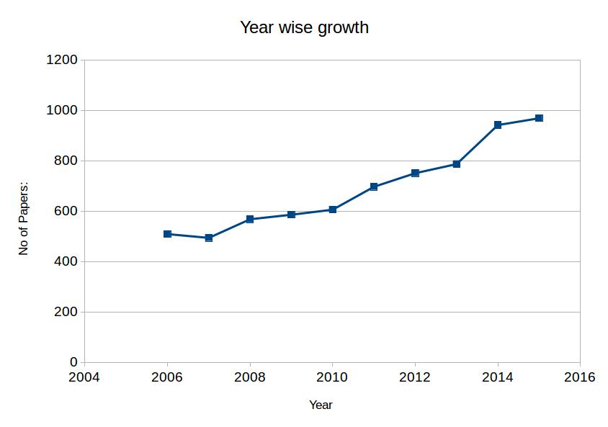

Table 3: Astronomy and astrophysics papers published by India - distributed by document type.

|  |  |  |  |  |
| --- | --- | --- | --- | --- |
| **Year** | **Article** | **Review** | **Proceedings paper** | **Letter** |
| 2006 | 498 | 11 | 71 |  |
| 2007 | 481 | 12 | 55 | 1 |
| 2008 | 543 | 24 | 43 | 1 |
| 2009 | 572 | 13 | 8 | 1 |
| 2010 | 598 | 8 | 11 |  |
| 2011 | 690 | 7 | 24 |  |
| 2012 | 739 | 12 | 3 |  |
| 2013 | 780 | 6 | 1 | 1 |
| 2014 | 934 | 7 | 7 | 1 |
| 2015 | 964 | 5 | 7 |  |

Table 3 shows the distribution of papers by document type of article, review, proceeding paper and letter.

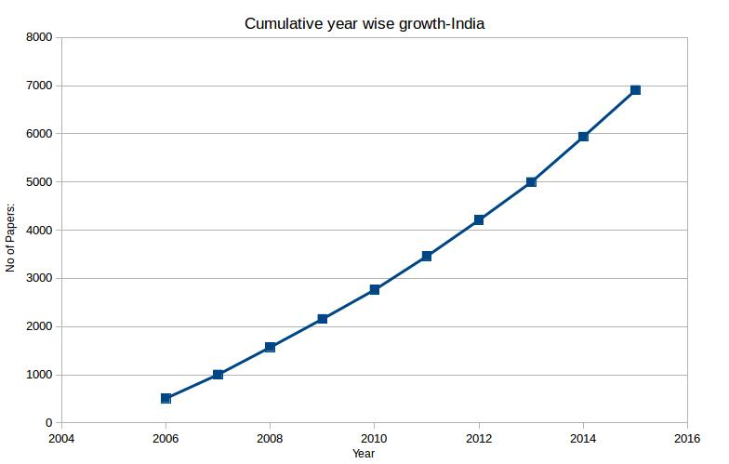

Table 4: Astronomy and astrophysics papers published by India - distributed by Web of Science categories

|  |  |  |  |  |  |  |  |
| --- | --- | --- | --- | --- | --- | --- | --- |
| **No.** | **Name** | **No. of papers** | **Sum of citations** | **CPP** | **% Documents in Top 1%** | **No. of papers with greater than 30 authors** | **Sum of citations\*** |
| 1 | ASTRONOMY & ASTROPHYSICS | 6606 | 120763 | 18.28 | 0.82 | 333 | 35945 |
| 2 | PHYSICS, PARTICLES & FIELDS | 1744 | 35442 | 20.32 | 0.92 | 83 | 9440 |
| 3 | GEOSCIENCES, MULTIDISCIPLINARY | 428 | 3099 | 7.24 | 0.23 | 2 | 16 |
| 4 | METEOROLOGY & ATMOSPHERIC SCIENCES | 412 | 3084 | 7.49 | 0 | 2 | 19 |
| 5 | PHYSICS, MULTIDISCIPLINARY | 386 | 8695 | 22.53 | 1.81 | 42 | 3196 |
| 6 | PHYSICS, NUCLEAR | 347 | 9198 | 26.51 | 1.44 | 4 | 4640 |
| 7 | PHYSICS, MATHEMATICAL | 167 | 1100 | 6.59 | 0.6 | 0 | 0 |
| 8 | GEOCHEMISTRY & GEOPHYSICS | 41 | 245 | 5.98 | 0 | 1 | 12 |
| 9 | REMOTE SENSING | 25 | 330 | 13.2 | 0 | 1 | 12 |
| 10 | ENGINEERING, AEROSPACE | 20 | 238 | 11.9 | 0 | 0 | 0 |
| 11 | PHYSICS, FLUIDS & PLASMAS | 19 | 137 | 7.21 | 0 | 0 | 0 |
| 12 | TELECOMMUNICATIONS | 17 | 147 | 8.65 | 0 | 1 | 12 |
| 13 | BIOLOGY | 13 | 122 | 9.38 | 0 | 1 | 9 |
| 14 | MECHANICS | 12 | 39 | 3.25 | 0 | 0 | 0 |
| 15 | COMPUTER SCIENCE, INTERDISCIPLINARY APPLICATIONS | 5 | 11 | 2.2 | 0 | 0 | 0 |
| 16 | EDUCATION, SCIENTIFIC DISCIPLINES | 4 | 6 | 1.5 | 0 | 0 | 0 |
| 17 | MATHEMATICS, INTERDISCIPLINARY APPLICATIONS | 3 | 54 | 18 | 0 | 0 | 0 |
| 18 | MULTIDISCIPLINARY SCIENCES | 1 | 111 | 111 | 0 | 1 | 111 |
| 19 | CHEMISTRY, PHYSICAL | 1 | 35 | 35 | 0 | 0 | 0 |
| 20 | BIOPHYSICS | 1 | 0 | 0 | 0 | 0 | 0 |
| 20 | INSTRUMENTS & INSTRUMENTATION | 1 | 0 | 0 | 0 | 0 | 0 |

Table 4 enlists the twenty categories of astronomy and astrophysics and the distribution of papers by these categories. The most number of publications come from Astronomy and Astrophysics, Particles and fields physics and geosciences and multidisciplinary categories.

Table 5: Astronomy and astrophysics papers published by India - distributed by journal

| **No** | **Journal Name** | **Journal country** | **Impact Factor\*\*** | **No. of Papers** | **% of 6909** | **Sum of citations** | **CPP** |
| --- | --- | --- | --- | --- | --- | --- | --- |
| 1 | Monthly Notices Of The Royal Astronomical Society | England | 4.95 | 967 | 14 | 14477 | 14.97 |
| 2 | Physical Review D | USA | 4.51 | 816 | 11.81 | 16692 | 20.46 |
| 3 | Astrophysics and Space Science | Netherlands | 1.68 | 781 | 11.3 | 5674 | 7.27 |
| 4 | Astrophysical Journal | USA | 5.91 | 664 | 9.61 | 11606 | 17.48 |
| 5 | Astronomy Astrophysics | France | 5.19 | 495 | 7.17 | 19981 | 40.37 |
| 6 | Advances in Space Research | England | 1.41 | 307 | 4.63 | 1667 | 5.88 |
| 7 | Journal Of Geophysical Research Space Physics | USA | 2.73 | 264 | 3.82 | 2573 | 9.75 |
| 8 | International Journal Of Modern Physics D | Singapore | 1.96 | 201 | 2.91 | 4363 | 21.71 |
| 9 | Physics Letters B | England | 4.79 | 199 | 2.88 | 8009 | 40.25 |
| 10 | Classical And Quantum Gravity | England | 2.84 | 176 | 2.55 | 3442 | 19.56 |
| 11 | Solar Physics | Netherlands | 2.86 | 171 | 2.48 | 1926 | 11.26 |
| 12 | Journal Of Cosmology And Astroparticle Physics | England | 5.63 | 163 | 2.36 | 1587 | 9.74 |
| 13 | Modern Physics Letters A | Singapore | 1.12 | 148 | 2.14 | 873 | 5.9 |
| 14 | Journal Of Astrophysics And Astronomy | India | 0.33 | 147 | 2.13 | 404 | 2.75 |
| 15 | Astrophysical Journal Letters | USA | 5.49 | 133 | 1.93 | 2538 | 19.08 |
| 16 | General Relativity And Gravitation | USA | 1.67 | 132 | 1.91 | *1551* | *11.75* |
| 17 | Bulletin Of The Astronomical Society Of India | India | 0.7 | 114 | 1.65 | 405 | 3.55 |
| 18 | New Astronomy | Netherlands | 1.09 | 103 | 1.49 | *584* | *5.67* |
| 19 | Planetary And Space Science | USA | 1.94 | 97 | 1.4 | *683* | *7.04* |
| 20 | Research In Astronomy And Astrophysics | China Mainland | 1.29 | 86 | 1.25 | *470* | *5.47* |
| 21 | Annales Geophysicae | Germany(Fed Rep Ger) | 1.73 | 74 | 1.07 | *866* | *11.7* |
| 22 | Physical Review Letters | USA | 7.65 | 73 | 1.06 | 3014 | 41.29 |
| 23 | Astronomical Journal | USA | 4.62 | 66 | 0.96 | *2276* | *34.48* |
| 24 | Nuclear Physics B | Netherlands | 3.74 | 56 | 0.81 | 659 | 11.77 |
| 25 | Astroparticle Physics | Netherlands | 3.43 | 53 | 0.77 | 609 | 11.49 |
| 26 | Gravitation Cosmology | Russia | 0.91 | 38 | 0.55 | *100* | 2.63 |
| 27 | Astrophysical Journal Supplement Series | USA | 11.26 | 33 | 0.48 | 5861 | 177.61 |
| 28 | Experimental Astronomy | Netherlands | 2.87 | 32 | 0.46 | 218 | 6.81 |
| 29 | Icarus | USA | 3.38 | 32 | 0.46 | 269 | 8.41 |
| 30 | Earth Moon And Planets | Netherlands | 0.66 | 31 | 0.45 | 90 | 2.9 |
| 31 | Astronomische Nachrichten | Germany(Fed Rep Ger) | 0.96 | 27 | 0.39 | 222 | 8.22 |
| 32 | Physical Review E | USA | 2.25 | 19 | 0.28 | 126 | 6.63 |
| 33 | Publications Of The Astronomical Society Of Australia | Australia | 3.25 | 19 | 0.28 | 314 | 16.53 |
| 34 | Publications Of The Astronomical Society Of Japan | Japan | 1.96 | 19 | 0.28 | 184 | 9.68 |
| 35 | Radio Science | USA | 1.27 | 17 | 0.25 | 137 | 8.06 |
| 36 | Publications Of The Astronomical Society Of The Pacific | USA | 4.42 | 15 | 0.22 | 272 | 18.13 |
| 37 | Space Science Reviews | Netherlands | 7.24 | 13 | 0.19 | 361 | 27.77 |
| 38 | Geophysical And Astrophysical Fluid Dynamics | England | 0.71 | 12 | 0.17 | 39 | 3.25 |
| 39 | Advances In Astronomy | USA | 0.81 | 10 | 0.15 | 3 | 0.3 |
| 40 | Astrophysics | Armenia | 0.74 | 10 | 0.15 | 7 | 0.7 |
| 41 | Nature | England | 38.14 | 10 | 0.15 | 887 | 88.7 |
| 42 | Astrobiology | USA | 2.63 | 8 | 0.12 | 78 | 9.75 |
| 43 | Astronomy Reports | Russia | 0.81 | 8 | 0.12 | 106 | 13.25 |
| 44 | Journal Of Space Weather And Space Climate | France | 2.85 | 6 | 0.07 | 29 | 5.6 |
| 45 | Space Weather The International Journal Of Research And Applications | USA | 2.4 | 6 | 0.09 | 20 | 3.33 |
| 46 | Astronomy And Computing | Netherlands | 1.92 | 5 | 0.07 | 10 | 2 |
| 47 | Chinese Journal Of Astronomy And Astrophysics | China Mainland | 0.85 | 5 | 0.07 | 10 | 2 |
| 48 | International Journal Of Astrobiology | USA | 1.18 | 5 | 0.07 | 35 | 7 |
| 49 | New Astronomy Reviews | Netherlands | 6.15 | 5 | 0.07 | 45 | 9 |
| 50 | European Journal Of Physics | England | 0.61 | 4 | 0.06 | 5 | 1.25 |
| 51 | Journal Of The Korean Astronomical Society | South Korea | 0.66 | 4 | 0.06 | 18 | 4.5 |
| 52 | Revista Mexicana De Astronomia Y Astrofisica | Mexico | 2.36 | 4 | 0.06 | 425 | 106.25 |
| 53 | Science | USA | 34.66 | 4 | 0.06 | 451 | 112.75 |
| 54 | Astrophysical Bulletin | Russia | 1.19 | 3 | 0.04 | 10 | 3.33 |
| 55 | Celestial Mechanics Dynamical Astronomy | Netherlands | 1.59 | 3 | 0.04 | 50 | 16.67 |
| 56 | Acta Astronomica | Poland | 2 | 2 | 0.03 | 9 | 4.5 |
| 57 | Astronomy Letters-A Journal Of Astronomy And Space Astrophysics | Russia | 0.96 | 2 | 0.03 | 6 | 3 |
| 58 | Baltic Astronomy | Lithuania | 0.35 | 2 | 0.03 | 1 | 0.5 |
| 59 | Cosmic Research | Russia | 0.61 | 2 | 0.03 | 2 | 1 |
| 60 | Serbian Astronomical Journal | Serbia | 0.43 | 2 | 0.03 | 0 | 0 |
| 61 | Astronomy Geophysics | England | 0.26 | 1 | 0.01 | 0 | 0 |
| 62 | Comptes Rendus Physique | France | 2.08 | 1 | 0.01 | 1 | 1 |
| 63 | Contributions of The Astronomical Observatory Skalnate Pleso | Slovakia | 0.39 | 1 | 0.01 | 1 | 1 |
| 64 | Living Reviews In Relativity | Germany | 32 | 1 | 0.01 | 11 | 11 |
| 65 | Proceedings of the National Academy of Sciences of the United States of America | USA | 9.42 | 1 | 0.01 | 34 | 34 |
| 66 | Solar System Research | Russia | 0.64 | 1 | 0.01 | 0 | 0 |

Table 5 lists the 66 journals in which Indian authors from our dataset have published their papers.

Note: Among the 75 journals that were shortlisted, the journal series, volumes and issues listed under different names were combined into their parent journal; ADVANCES IN SPACE RESEARCH

1. ADVANCES IN SPACE RESEARCH SERIES

2. ADVANCES IN SPECIFYING PLASMA TEMPERATURES AND ION COMPOSITION IN THE IONOSPHERE

3. BOUNDARY LAYERS WAVES AND NON LINEAR DYNAMICAL PROCESSES

4. CORONAL MASS EJECTIONS AND SOLAR PARTICLE EVENTS IN SOLAR CYCLE 23

5. GREAT HISTORICAL GEOMAGNETIC STORM OF 1859 A MODERN LOOK

6. MOON AND NEAR EARTH OBJECTS

7. NATURAL HAZARDS AND OCEANOGRAPHIC PROCESSES FROM SATELLITE DATA

8. NEXT GENERATION OF SCIENTIFIC BALLOON MISSIONS

9. SPACE LIFE SCIENCES FLIGHT MEASUREMENTS CALIBRATION OF DETECTORS AND ENVIRONMENTAL MODELS FOR RADIATION ANALYSIS

Table 6: Journals grouped by their impact factors

|  |  |  |  |  |
| --- | --- | --- | --- | --- |
| **IF range** | **No. of Journals** | **No. of papers** | **Sum of citations** | **CPP** |
| IF=0 |  |  |  |  |
| 0.001-0.999 | 19 | 421 | 1419 | 3.37 |
| 1.000-1.999 | 15 | 1981 | 17157 | 8.66 |
| 2.000-2.999 | 11 | 689 | 8847 | 12.84 |
| 3.000-3.999 | 4 | 160 | 1851 | 11.57 |
| 4.000-4.999 | 5 | 2063 | 41726 | 20.23 |
| 5.000-5.999 | 4 | 1455 | 35712 | 24.54 |
| 6.000-6.999 | 1 | 5 | 45 | 9.00 |
| 7.000-7.999 | 2 | 86 | 3375 | 39.24 |
| 8.000-8.999 | 0 | 0 | 0 | 0 |
| 9.000-9.999 | 1 | 1 | 34 | 34.00 |
| 10.000-14.999 | 1 | 33 | 5861 | 177.61 |
| 15.000-19.999 | 0 | 0 | 0 |  |
| >=20 | 3 | 15 | 1349 | 89.93 |

Table 7: Top 50 institutions contributing to A&A Publications

|  |  |  |  |  |  |  |  |  |
| --- | --- | --- | --- | --- | --- | --- | --- | --- |
| **No.** | **Institution** | **No. of papers** | **No. of journals used** | **Sum of Citations** | **CPP** | **No. of papers with greater than 30 authors\*** | **Sum of Citations\*** | **CPP\*** |
| 1 | Tata Inst Fundamental Res | 1082 | 46 | 24666 | 22.8 | 99 | 10995 | 111.1 |
| 2 | Inter Univ Ctr Astron & Astrophys, Pune | 878 | 39 | 31303 | 35.65 | 142 | 19380 | 136.5 |
| 3 | Indian Inst Astrophys, Bangalore | 692 | 37 | 10675 | 15.43 | 31 | 3122 | 100.7 |
| 4 | Phys Res Lab, Ahmadabad | 386 | 35 | 3861 | 10 | 7 | 174 | 24.86 |
| 5 | Raman Res Inst, Bangalore | 370 | 31 | 6039 | 16.32 | 69 | 2208 | 32 |
| 6 | Aryabhatta Res Inst Observ Sci, Nainital | 362 | 26 | 4847 | 13.39 | 17 | 848 | 49.88 |
| 7 | Indian Inst Sci, Bangalore | 251 | 30 | 3505 | 13.96 | 1 | 4 | 4 |
| 8 | Jadavpur Univ, Kolkata | 207 | 17 | 2027 | 9.79 | 0 | 0 | 0 |
| 9 | Harish Chandra Res Inst, Allahabad | 200 | 18 | 3212 | 16.06 | 0 | 0 | 0 |
| 10 | SN Bose Natl Ctr Basic Sci, Kolkata | 189 | 25 | 3004 | 15.89 | 0 | 0 | 0 |
| 11 | Saha Inst Nucl Phys, Kolkata | 164 | 21 | 1941 | 11.84 | 24 | 1006 | 41.92 |
| 12 | Indian Inst Geomagnetism, Mumbai | 154 | 16 | 1360 | 8.83 | 0 | 0 | 0 |
| 13 | Indian Inst Technol Bhu, Varanasi | 151 | 30 | 1218 | 8.07 | 4 | 148 | 37 |
| 14 | Jamia Millia Islamia, New Delhi | 141 | 13 | 2371 | 16.82 | 0 | 0 | 0 |
| 15 | Univ Delhi, New Delhi | 135 | 26 | 1612 | 11.94 | 0 | 0 | 0 |
| 16 | Vikram Sarabhai Space Res Ctr, Trivandrum | 111 | 15 | 1188 | 10.7 | 0 | 0 | 0 |
| 17 | Indian Inst Technol, Kanpur | 106 | 22 | 1167 | 11.01 | 1 | 22 | 22 |
| 18 | Indian Inst Technol, Kharagpur | 95 | 21 | 1323 | 13.93 | 1 | 18 | 18 |
| 19 | Indian Space Res Org, Bangalore | 88 | 16 | 683 | 7.76 | 0 | 0 | 0 |
| 20 | Indian Ctr Space Phys, Kolkata | 85 | 17 | 785 | 9.24 | 0 | 0 | 0 |
| 21 | Univ Calcutta, Kolkata | 80 | 21 | 677 | 8.46 | 0 | 0 | 0 |
| 22 | Indian Inst Sci Educ & Res, Kolkata | 71 | 17 | 1251 | 17.62 | 21 | 910 | 43.33 |
| 23 | Udaipur Solar Observ, Udaipur | 70 | 15 | 740 | 10.57 | 0 | 0 | 0 |
| 24 | Bhabha Atom Res Ctr, Mumbai | 69 | 18 | 591 | 8.57 | 8 | 683 | 85.38 |
| 25 | Inst Math Sci, Chennai | 67 | 9 | 986 | 14.72 | 0 | 0 | 0 |
| 26 | Indian Assoc Cultivat Sci, Kolkata | 66 | 9 | 740 | 11.21 | 0 | 0 | 0 |
| 27 | Kumaun Univ, Nainital | 66 | 13 | 758 | 11.48 | 0 | 0 | 0 |
| 28 | Andhra Univ, Visakhapatnam | 62 | 5 | 623 | 10.05 | 0 | 0 | 0 |
| 29 | Indian Inst Technol, Roorkee | 62 | 15 | 518 | 8.35 | 0 | 0 | 0 |
| 30 | N Bengal Univ, Darjeeling | 60 | 14 | 675 | 11.25 | 0 | 0 | 0 |
| 31 | Natl Atmospher Res Lab, Gadanki | 60 | 5 | 392 | 6.53 | 0 | 0 | 0 |
| 32 | Indian Stat Inst, Kolkata | 55 | 18 | 463 | 8.42 | 0 | 0 | 0 |
| 33 | Bengal Engn & Sci Univ, Howrah | 50 | 10 | 508 | 10.16 | 0 | 0 | 0 |
| 34 | Visva Bharati Univ, W Bengal | 50 | 10 | 388 | 7.76 | 5 | 317 | 63.4 |
| 35 | Indian Inst Sci Educ & Res, Pune | 48 | 15 | 418 | 8.71 | 2 | 110 | 55 |
| 36 | Indian Inst Technol, Mumbai | 48 | 16 | 479 | 9.98 | 1 | 111 | 111 |
| 37 | Indian Inst Sci Educ & Res, Trivandrum | 47 | 10 | 852 | 18.13 | 21 | 849 | 40.43 |
| 38 | Univ Calicut, Calicut | 43 | 14 | 651 | 15.14 | 0 | 0 | 0 |
| 39 | Indian Space Res Org, Ahmadabad | 40 | 8 | 136 | 3.4 | 0 | 0 | 0 |
| 40 | Assam Univ, Silchar | 39 | 18 | 289 | 7.41 | 2 | 83 | 41.5 |
| 41 | Cochin Univ Sci & Technol, Cochin | 39 | 9 | 209 | 5.36 | 0 | 0 | 0 |
| 42 | Indian Inst Technol, Delhi | 39 | 8 | 134 | 3.44 | 0 | 0 | 0 |
| 43 | Aligarh Muslim Univ, Aligarh | 38 | 12 | 361 | 9.5 | 0 | 0 | 0 |
| 44 | Utkal Univ, Bhubaneswar | 35 | 13 | 953 | 27.23 | 0 | 0 | 0 |
| 45 | Mvgr Coll Engn, Vizainagaram | 33 | 1 | 312 | 9.45 | 0 | 0 | 0 |
| 46 | Univ Hyderabad, Hyderabad | 32 | 11 | 312 | 9.75 | 0 | 0 | 0 |
| 47 | Arul Anandar Coll, Karumathur | 31 | 6 | 190 | 6.13 | 0 | 0 | 0 |
| 48 | Guwahati Univ, Guwahati | 31 | 11 | 122 | 3.94 | 0 | 0 | 0 |
| 49 | Hindu Postgrad Coll, Ghazipur | 31 | 5 | 617 | 19.9 | 0 | 0 | 0 |
| 50 | Presidency Univ, Kolkata | 31 | 9 | 222 | 7.16 | 0 | 0 | 0 |

Table 8. Collaborating countries

|  |  |  |  |  |
| --- | --- | --- | --- | --- |
| **No.** | **Name** | **No. of papers** | **Sum of citations** | **CPP** |
| 1 | USA | 1542 | 61731 | 40.03 |
| 2 | GERMANY (FED REP GER) | 774 | 45744 | 59.1 |
| 3 | UNITED KINGDOM | 663 | 48019 | 72.43 |
| 4 | FRANCE | 628 | 39732 | 63.27 |
| 5 | ITALY | 513 | 37412 | 72.93 |
| 6 | JAPAN | 413 | 25437 | 61.59 |
| 7 | SPAIN | 398 | 37356 | 93.86 |
| 8 | RUSSIA | 386 | 29764 | 77.11 |
| 9 | AUSTRALIA | 363 | 24174 | 66.6 |
| 10 | CANADA | 321 | 32690 | 101.84 |
| 11 | NETHERLANDS | 299 | 24336 | 81.39 |
| 12 | POLAND | 235 | 22132 | 94.18 |
| 13 | SOUTH KOREA | 227 | 13529 | 59.6 |
| 14 | CHINA MAINLAND | 219 | 15004 | 68.51 |
| 15 | TAIWAN | 214 | 16867 | 78.82 |
| 16 | SOUTH AFRICA | 205 | 19184 | 93.58 |
| 17 | CHILE | 203 | 20425 | 100.62 |
| 18 | SWITZERLAND | 174 | 23604 | 135.66 |
| 19 | SWEDEN | 158 | 10722 | 67.86 |
| 20 | BRAZIL | 148 | 6315 | 42.67 |
| 21 | DENMARK | 146 | 16668 | 114.16 |
| 22 | FINLAND | 117 | 18655 | 159.44 |
| 23 | BELGIUM | 109 | 12533 | 114.98 |
| 24 | HUNGARY | 106 | 9057 | 85.44 |
| 25 | Other 69 more countries | 1479 | 103786 |  |

Table 9. Prolific authors

| Rank | Name | Affiliation | No. of papers | Sum of citations | CPP |
| --- | --- | --- | --- | --- | --- |
| 1 | Mitra, S. | Inter-University Centre for Astronomy & Astrophysics | 80 | 13445 | 168.06 |
| 2 | Dhurandhar, S. | Inter-University Centre for Astronomy & Astrophysics | 69 | 4550 | 65.94 |
| 3 | Chakrabarti, Sandip K. | SN Bose National Centre for Basic Science | 67 | 694 | 10.36 |
| 4 | Srianand, R. | Inter-University Centre for Astronomy & Astrophysics | 60 | 1738 | 28.97 |
| 5 | Saikia, D. J. | Tata Institute of Fundamental Research | 48 | 767 | 15.98 |
| 6 | Ashok, N. M. | Physical Research Laboratory - India | 46 | 629 | 13.67 |
| 7 | Ojha, D. K. | Tata Institute of Fundamental Research | 44 | 510 | 11.59 |
| 8 | Paul, Biswajit | Raman Research Institute | 42 | 376 | 8.95 |
| 9 | Banerjee, D. P. K. | Physical Research Laboratory - India | 42 | 622 | 14.81 |
| 10 | Subrahmanyan, R. | Raman Research Institute | 41 | 947 | 23.1 |
| 11 | Shankar, N. Udaya | Raman Research Institute | 41 | 822 | 20.05 |
| 12 | Anupama, G. C. | Indian Institute of Astrophysics | 41 | 660 | 16.1 |
| 13 | Souradeep, Tarun | Inter-University Centre for Astronomy & Astrophysics | 40 | 572 | 14.3 |
| 14 | Chakraborty, Subenoy | Jadavpur University | 39 | 298 | 7.64 |
| 15 | Srivani, K. S. | Raman Research Institute | 38 | 803 | 21.13 |
| 16 | Padmanabhan, T. | Inter-University Centre for Astronomy & Astrophysics | 37 | 821 | 22.19 |
| 17 | Pandey, A. K. | Aryabhatta Research Institute of Observational Sciences | 36 | 445 | 12.36 |
| 18 | Debnath, Ujjal | Indian Institute of Engineering Science Technology Shibpur (IIEST) | 36 | 320 | 8.89 |
| 19 | Unnikrishnan, C. S. | Tata Institute of Fundamental Research | 36 | 932 | 25.89 |
| 20 | Mukhopadhyay, Banibrata | Indian Institute of Science (IISC) - Bangalore | 35 | 351 | 10.03 |
| 21 | Nagendra, K. N. | Indian Institute of Astrophysics | 34 | 272 | 8 |
| 22 | Mookerjea, B. | Tata Institute of Fundamental Research | 33 | 1026 | 31.09 |
| 23 | Antia, H. M. | Tata Institute of Fundamental Research | 33 | 735 | 22.27 |
| 24 | Rao, A. R. | Tata Institute of Fundamental Research | 32 | 236 | 7.38 |
| 25 | Subramanian, Kandaswamy | Inter-University Centre for Astronomy & Astrophysics | 32 | 691 | 21.59 |
| 26 | Sharma, R. P. | Indian Institute of Technology (IIT) | 32 | 88 | 2.75 |
| 27 | Sharma, R. P. | Indian Institute of Technology (IIT) - Delhi | 32 | 88 | 2.75 |
| 28 | Rahaman, Farook | Jadavpur University | 32 | 430 | 13.44 |
| 29 | Sahu, D. K. | Indian Institute of Astrophysics | 31 | 573 | 18.48 |
| 30 | Sarkar, Utpal | Physical Research Laboratory - India | 31 | 519 | 16.74 |
| 31 | Jain, Pankaj | Indian Institute of Technology (IIT) - Kanpur | 30 | 321 | 10.7 |
| 32 | Prabu, T. | Raman Research Institute | 29 | 587 | 20.24 |
| 33 | Bharadwaj, Somnath | Indian Institute of Technology (IIT) - Kharagpur | 29 | 465 | 16.03 |
| 34 | Oberoi, D. | Tata Institute of Fundamental Research | 28 | 476 | 17 |
| 35 | Joshi, Pankaj S. | Tata Institute of Fundamental Research | 28 | 474 | 16.93 |
| 36 | Murthy, Jayant | Indian Institute of Astrophysics | 27 | 134 | 4.96 |
| 37 | Chengalur, Jayaram N. | Tata Institute of Fundamental Research | 27 | 509 | 18.85 |
| 38 | Gupta, Alok C. | Aryabhatta Research Institute of Observational Sciences | 27 | 458 | 16.96 |
| 39 | Sami, M. | Jamia Millia Islamia | 27 | 699 | 25.89 |
| 40 | Banerjee, Rabin | SN Bose National Centre for Basic Science | 26 | 1328 | 51.08 |
| 41 | Rao, V. U. M. | Andhra University | 26 | 265 | 10.19 |
| 42 | Singh, K. P. | Tata Institute of Fundamental Research | 26 | 153 | 5.88 |
| 43 | Nath, Biman B. | Raman Research Institute | 26 | 295 | 11.35 |
| 44 | Chatterjee, Prasanta | Visva Bharati University | 26 | 290 | 11.15 |
| 45 | Sen, Anjan A. | Jamia Millia Islamia | 25 | 217 | 8.68 |
| 46 | Kuriakose, V. C. | Cochin University Science & Technology | 25 | 153 | 6.12 |
| 47 | Ravindra, B. | Indian Institute of Astrophysics | 25 | 157 | 6.28 |
| 48 | Gupta, R. | Inter-University Centre for Astronomy & Astrophysics | 25 | 1060 | 42.4 |
| 49 | Kumar, Brijesh | Aryabhatta Research Institute of Observational Sciences | 25 | 299 | 11.96 |
| 50 | Sampoorna, M. | Indian Institute of Astrophysics | 24 | 208 | 8.67 |
| 51 | Souradeep, T. | Inter-University Centre for Astronomy & Astrophysics | 24 | 2157 | 89.88 |
| 52 | Sengupta, Soumitra | Indian Association for the Cultivation of Science (IACS) – Jadavpur | 24 | 165 | 6.88 |
| 53 | Dwivedi, B. N. | Banaras Hindu University | 24 | 233 | 9.71 |
| 54 | Rajalakshmi, G. | Tata Institute of Fundamental Research | 23 | 867 | 37.7 |
| 55 | Srivastava, A. K. | Aryabhatta Research Institute of Observational Sciences | 23 | 410 | 17.83 |
| 56 | Stalin, C. S. | Indian Institute of Astrophysics | 23 | 303 | 13.17 |
| 57 | Iyer, B. R. | Raman Research Institute | 23 | 885 | 38.48 |
| 58 | Singh, A. K. | Banaras Hindu University | 22 | 158 | 7.18 |
| 59 | Singh, Harinder P. | University of Delhi | 22 | 171 | 7.77 |
| 60 | Banerjee, D. | Indian Institute of Astrophysics | 22 | 395 | 17.95 |
| 61 | Haris, K. | Indian Institute of Science Education & Research (IISER) – Thiruvananthapuram | 22 | 851 | 38.68 |
| 62 | Mazumder, N. | Indian Institute of Science Education & Research (IISER) – Thiruvananthapuram | 22 | 871 | 39.59 |
| 63 | Dadhich, Naresh | Inter-University Centre for Astronomy & Astrophysics | 22 | 227 | 10.32 |
| 64 | Subrahmanyan, Ravi | Raman Research Institute | 22 | 646 | 29.36 |
| 65 | Gopal-Krishna | Tata Institute of Fundamental Research | 21 | 210 | 10 |
| 66 | Ramesh, R. | Indian Institute of Astrophysics | 21 | 279 | 13.29 |
| 67 | Kumar, A. | Institute for Plasma Research (IPR) | 21 | 849 | 40.43 |
| 68 | Sahni, Varun | Inter-University Centre for Astronomy & Astrophysics | 21 | 631 | 30.05 |
| 69 | Deshpande, A. A. | Raman Research Institute | 21 | 327 | 15.57 |
| 70 | Naik, Sachindra | Physical Research Laboratory – India | 21 | 216 | 10.29 |
| 71 | Pai, A. | Indian Institute of Science Education & Research (IISER) – Thiruvananthapuram | 21 | 849 | 40.43 |
| 72 | Venkatakrishnan, P. | Physical Research Laboratory – India | 21 | 242 | 11.52 |
| 73 | Sagar, Ram | Aryabhatta Research Institute of Observational Sciences | 20 | 214 | 10.7 |
| 74 | Dwarakanath, K. S. | Raman Research Institute | 20 | 184 | 9.2 |
| 75 | Sivarani, Thirupathi | Indian Institute of Astrophysics | 20 | 2955 | 147.75 |
| 76 | Misra, Ranjeev | Inter-University Centre for Astronomy & Astrophysics | 20 | 139 | 6.95 |
| 77 | Pandey, S. B. | Aryabhatta Research Institute of Observational Sciences | 20 | 687 | 34.35 |
| 78 | Umapathy, S. | Madurai Kamaraj University | 20 | 116 | 5.8 |
| 79 | Kantharia, N. G. | Tata Institute of Fundamental Research | 20 | 122 | 6.1 |
| 80 | Ishwara-Chandra, C. H. | Tata Institute of Fundamental Research | 20 | 203 | 10.15 |
| 81 | Ghosh, S. K. | Tata Institute of Fundamental Research | 20 | 215 | 10.75 |

|  |
| --- |
| Main Information about data |
|  |
| Articles 6910 |
| Sources (Journals, Books, etc.) 75 |
| Keywords Plus (ID) 12338 |
| Author's Keywords (DE) 7722 |
| Period 2006 - 2015 |
| Average citations per article 17.04 |
|  |
| Authors 24040 |
| Author Appearances 146715 |
| Authors of single authored articles 73 |
| Authors of multi authored articles 23967 |
|  |
| Articles per Author 0.287 |
| Authors per Article 3.48 |
| Co-Authors per Articles 21.2 |
| Collaboration Index 3.84 |
|  |
|  |
| Annual Scientific Production |
|  |
| Year Articles |
| 2006 510 |
| 2007 494 |
| 2008 568 |
| 2009 586 |
| 2010 606 |
| 2011 697 |
| 2012 751 |
| 2013 787 |
| 2014 942 |
| 2015 969 |
|  |
| Annual Percentage Growth Rate 7.392171 |
|  |
|  |
| Most Productive Authors |
|  |
| Authors Articles Authors Articles Fractionalized |
| 1 MITRA S 128 CHAKRABORTY S 50.4 |
| 2 CHAKRABORTY S 109 PADMANABHAN T 42.4 |
| 3 BOSE S 99 CHAKRABARTI SK 33.0 |
| 4 TAYLOR R 99 KUMAR S 26.4 |
| 5 CHAKRABARTI SK 95 DEBNATH U 23.8 |
| 6 MUKHERJEE S 95 SENGUPTA S 22.9 |
| 7 SRIANAND R 95 GHOSH S 21.9 |
| 8 ZHANG L 95 MUKHOPADHYAY B 21.5 |
| 9 CHEN Y 94 SRIANAND R 20.9 |
| 10 GHOSH S 93 SOURADEEP T 20.1 |

|  |
| --- |
| Countries collaborating frequently with India |
|  |
| Country Articles Freq |
| 1 INDIA 4984 0.72221 |
| 2 USA 528 0.07651 |
| 3 FRANCE 161 0.02333 |
| 4 GERMANY 148 0.02145 |
| 5 ITALY 124 0.01797 |
| 6 AUSTRALIA 89 0.01290 |
| 7 ENGLAND 81 0.01174 |
| 8 JAPAN 76 0.01101 |
| 9 SPAIN 56 0.00811 |
| 10 KOREA 54 0.00782 |
|  |
|  |
| Total Citations per Country |
|  |
| Country Total Citations Average Article Citations |
| 1 INDIA 48837 9.80 |
| 2 USA 22797 43.18 |
| 3 ENGLAND 9306 114.89 |
| 4 ITALY 7443 60.02 |
| 5 FRANCE 7310 45.40 |
| 6 GERMANY 3659 24.72 |
| 7 AUSTRALIA 2242 25.19 |
| 8 JAPAN 1932 25.42 |
| 9 NETHERLANDS 1799 40.89 |
| 10 SPAIN 1789 31.95 |
|  |
|  |
| Most Relevant Sources |
|  |
| Sources Articles |
| 1 MONTHLY NOTICES OF THE ROYAL ASTRONOMICAL SOCIETY 967 |
| 2 PHYSICAL REVIEW D 816 |
| 3 ASTROPHYSICS AND SPACE SCIENCE 781 |
| 4 ASTROPHYSICAL JOURNAL 664 |
| 5 ASTRONOMY & ASTROPHYSICS 495 |
| 6 ADVANCES IN SPACE RESEARCH 292 |
| 7 JOURNAL OF GEOPHYSICAL RESEARCH-SPACE PHYSICS 264 |
| 8 INTERNATIONAL JOURNAL OF MODERN PHYSICS D 201 |
| 9 PHYSICS LETTERS B 199 |
| 10 CLASSICAL AND QUANTUM GRAVITY 176 |
|  |
|  |
| Most Relevant Keywords |
|  |
| Author Keywords (DE) Articles Keywords-Plus (ID) Articles |
| 1 GALAXIES: ACTIVE 235 MODEL 411 |
| 2 DARK ENERGY 147 UNIVERSE 399 |
| 3 BLACK HOLE PHYSICS 129 EMISSION 374 |
| 4 POLARIZATION 121 EVOLUTION 374 |
| 5 MAGNETIC FIELDS 120 MODELS 262 |
| 6 GALAXIES: EVOLUTION 113 FIELD 253 |
| 7 X-RAYS: BINARIES 111 GENERAL-RELATIVITY 253 |
| 8 GALAXIES: 110 SUPERNOVAE 239 |
| 9 SUN: CORONA 110 CONSTRAINTS 229 |
| 10 GALAXIES: ISM 104 ACTIVE GALACTIC NUCLEI 224 |

### Images and Graphs:

Location: Section2: Scientometrics- Astronomy&Astrophysics/ Images and Graphs

Graphs visualized with Gephi, VosViewer, Microsoft Excel and R.

The below graphs have been obtained by using Vos Viewer and data files from Web of Science. Some of the graphs have been obtained using R libraries for bibliometrics.

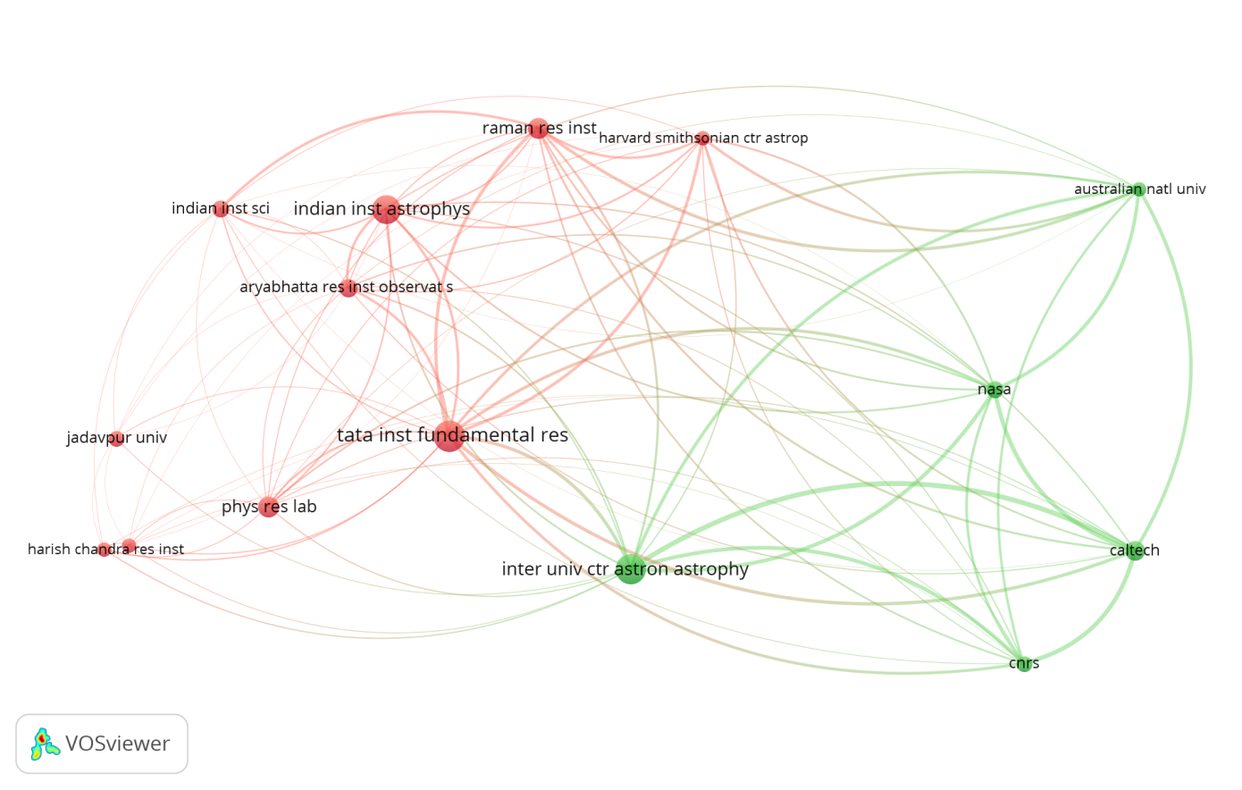

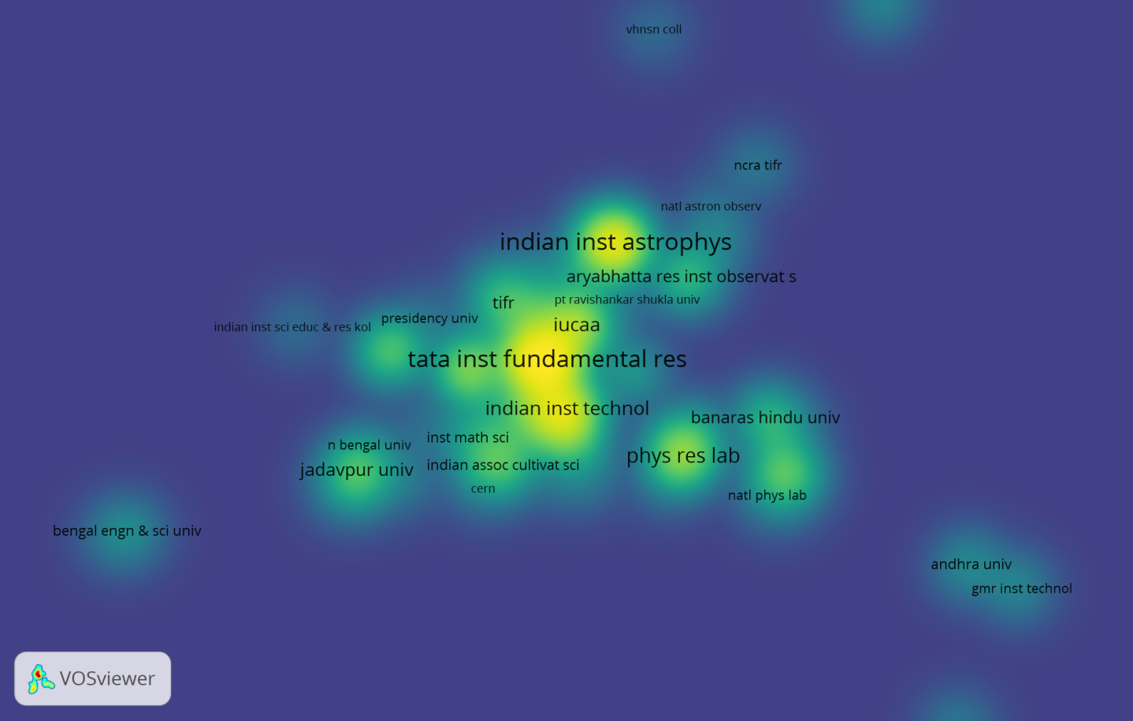

Country Collaboration graphs:

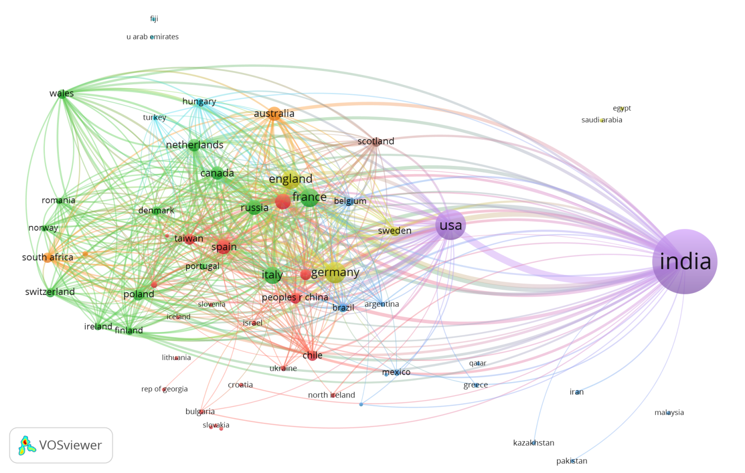



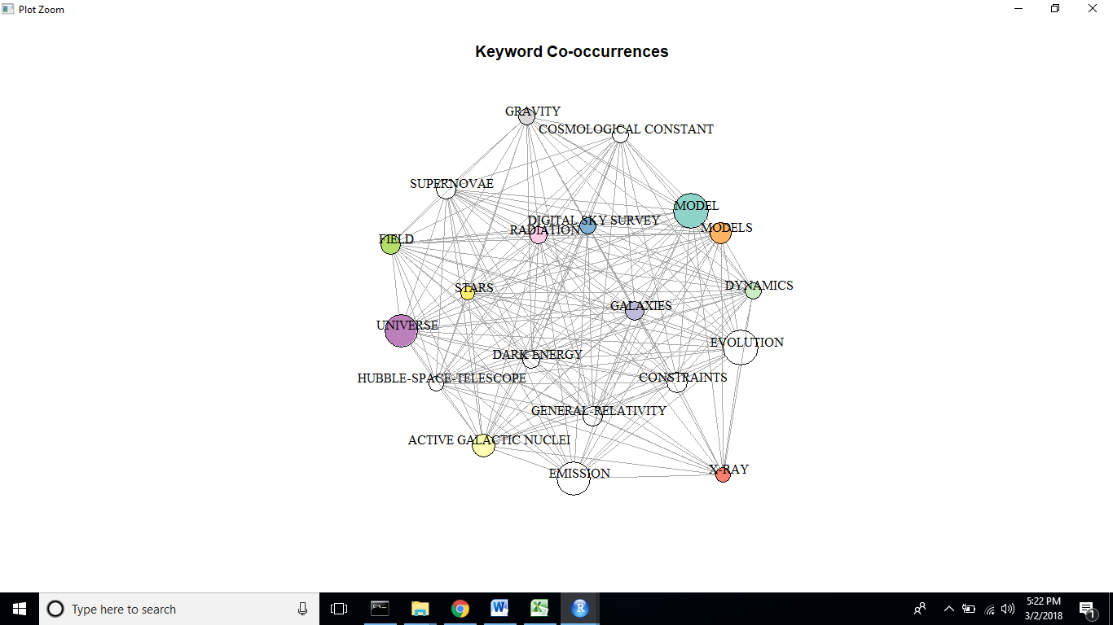

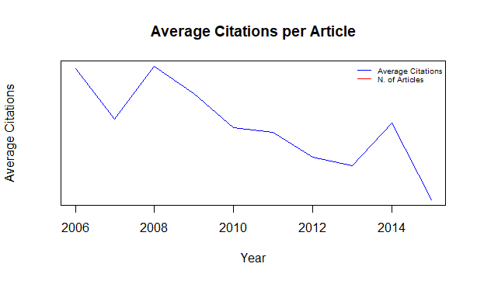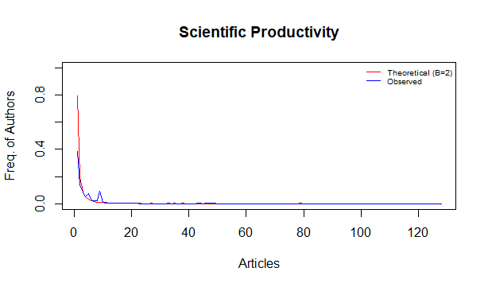

Top 15 institutions collaboration graph: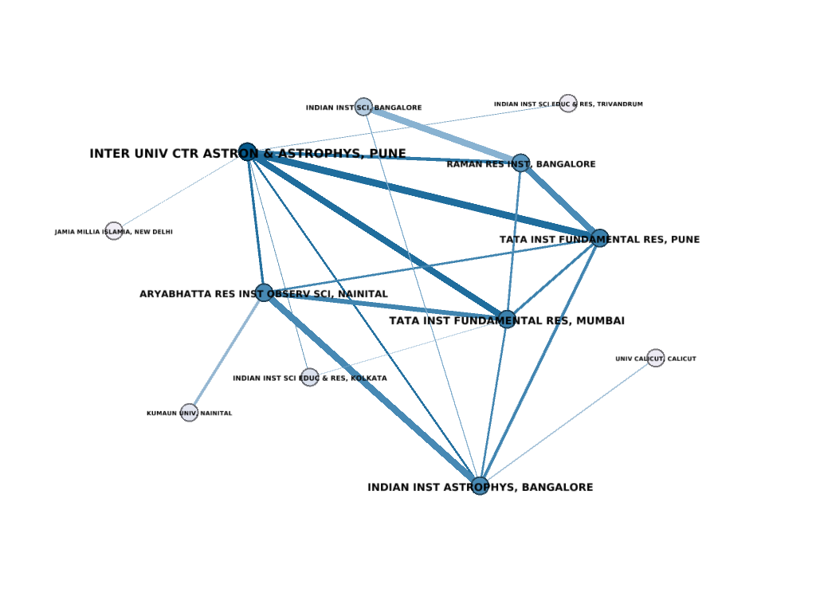

Most productive author’s collaboration graph:

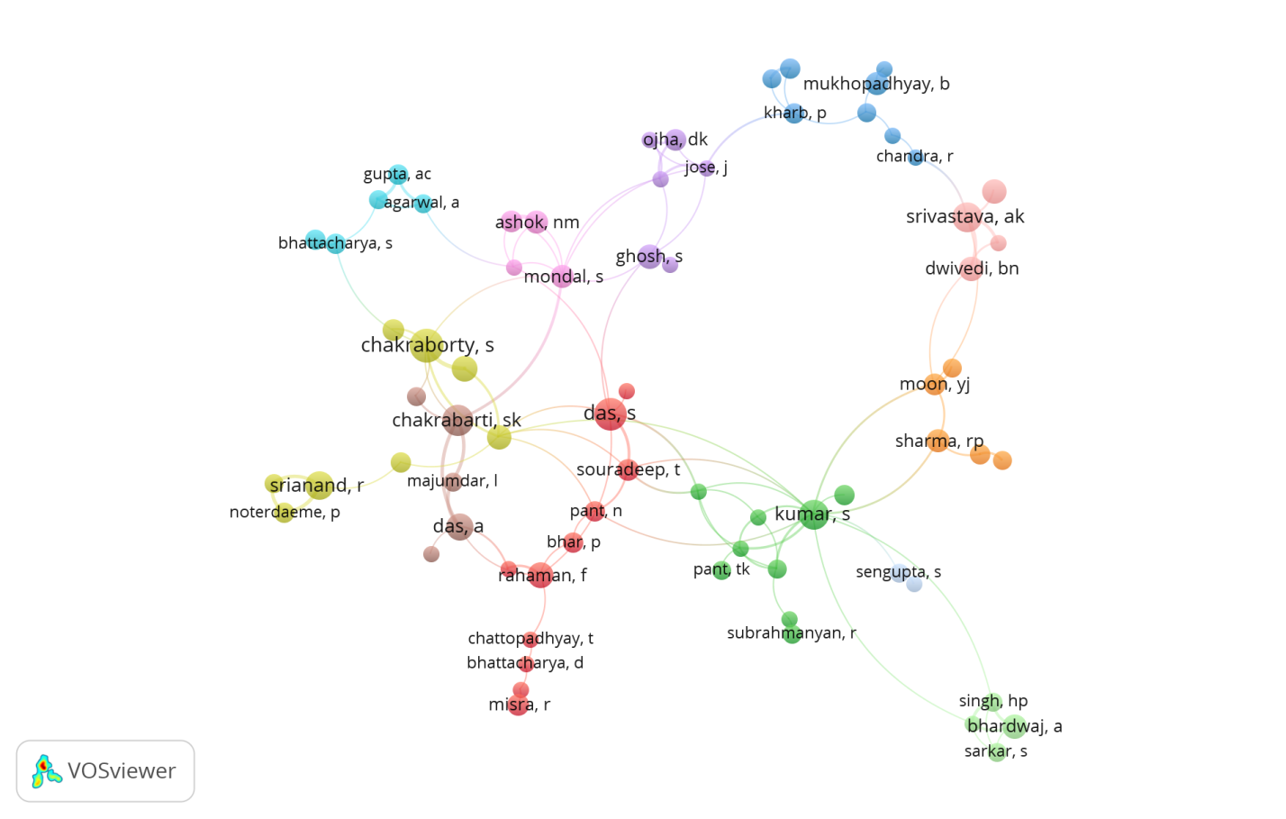

Keywords co-occurrence graph:

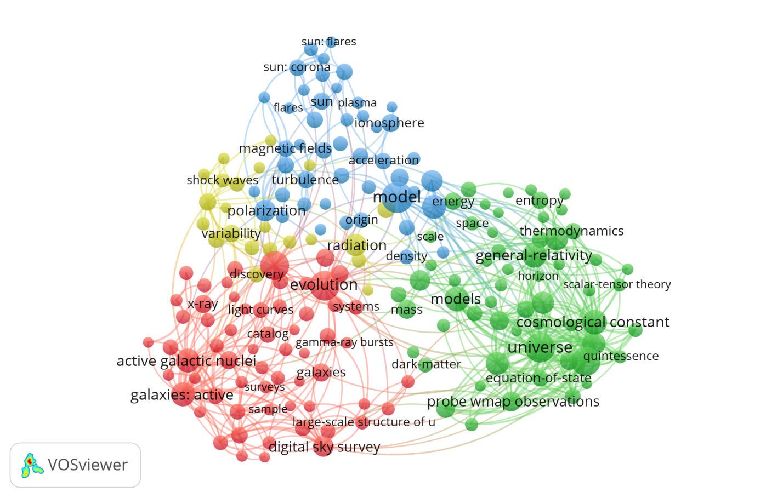

Co-citation network for countries graph:

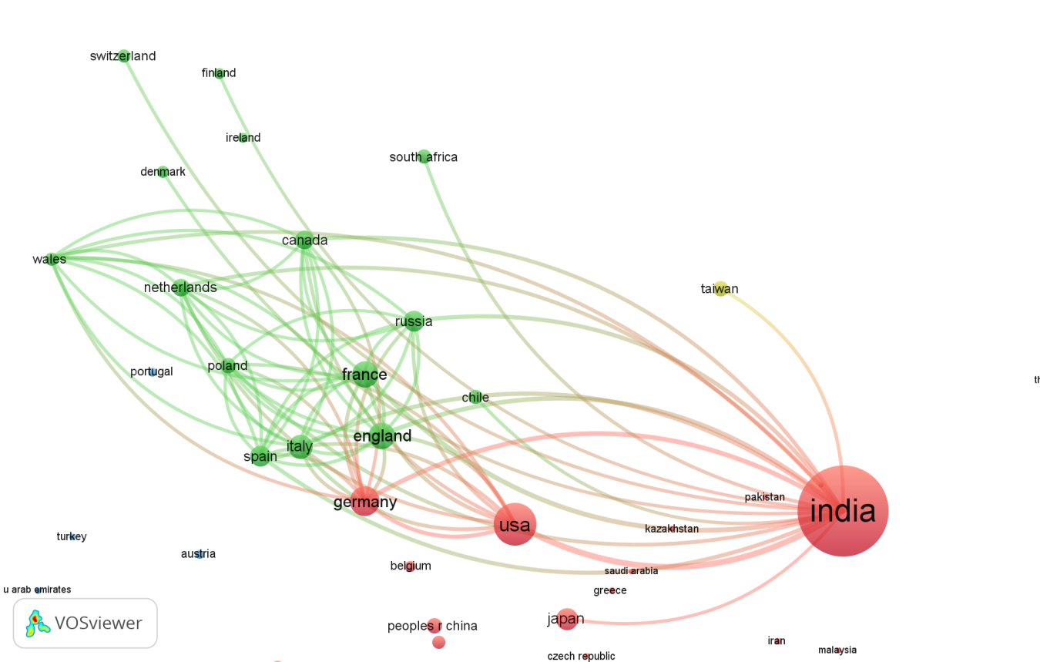

Folder Location: CPR- Abinitha/Section2: Scientometrics- Astronomy&Astrophysics

### A&A Data-Plain Text:

The plain text data (14 .txt files) downloaded from Web of Science in July 2017.

### InCites Data:

Data collected from InCites with author count filters.

# Folders Hierarchy:

**CPR- Abinitha**

**Section2: Scientometrics- Astronomy and Astrophysics**

A&A Data-Plain Text

Graphs and Images

Incites Data

Tables and Charts

Analysis

HTML

SciVal Data

WUR

**Section1: CPR-WUR**